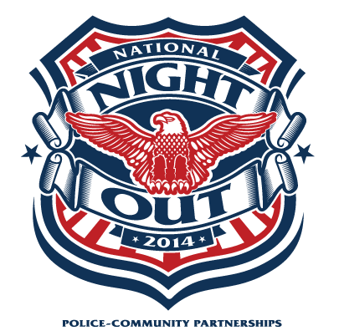
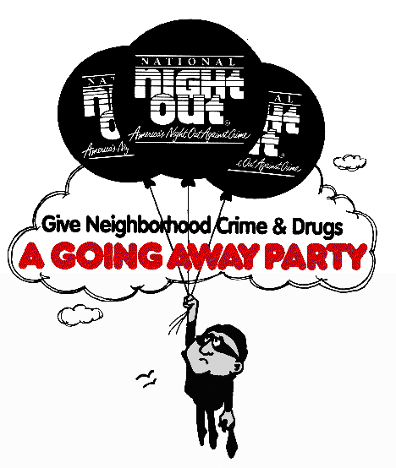
31st ANNUAL National Night Out
OFFICIAL REGISTRATION FORM

OCTOBER 7, 2014

Name:____________________________________________________
Sub-Division: ______________________________________________
Mailing Address:___________________________________________
__________________________________________________________
Exact Location of your NNO party:____________________________
Telephone: _______________Email:___________________________
Affiliated Police or Sheriff’s Department: Kyle Police Department
Size of area you hope to organize (i.e., number of homes, number of attendees) _________________________________________________
__________________________________________________________
Did your area participate in National Night Out 2012? Yes No
Additional Information: _____________________________________

- This form must be returned in order to: (1) Officially register your area;
(2) Receive NNO material
YOU MUST REGISTER EACH YEAR

OFFICE Use Only:
Date Received: __________

Please return form ASAP to:
Kyle Police Department
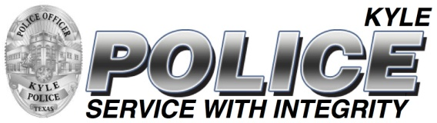
Attn: James Plant
PO Box 40
Kyle, Texas 78640

Questions? Call 512.268.0859 or
Email: jplant@cityofkyle.com
www.cityofkyle.com/police

