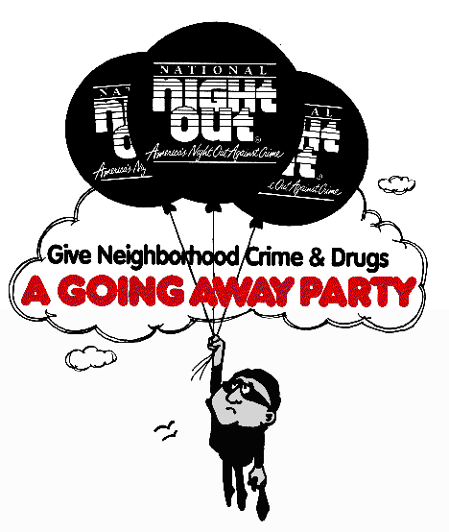
32st ANNUAL National Night Out
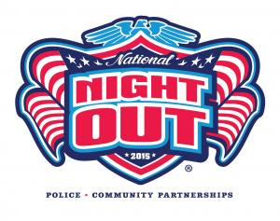
OFFICIAL REGISTRATION FORM

OCTOBER 6, 2015

Name:_____________________________________________________
Sub-Division: ______________________________________________
Mailing Address:____________________________________________
Exact Location of your NNO party:______________________________
__________________________________________________________
Telephone: ________________Email:___________________________
Affiliated Police or Sheriff’s Department: Kyle Police Department
Size of area you hope to organize (i.e. number of homes, number of attendees) _________________________________________________
__________________________________________________________
Did your area participate in National Night Out 2014? Yes No
Additional Information: ______________________________________
__________________________________________________________

- This form must be returned in order to: (1) Officially register your area;
(2) Receive NNO material
YOU MUST REGISTER EACH YEAR

Questions? Call 512.268.0859 or
Email: jplant@cityofkyle.com
www.cityofkyle.com/police
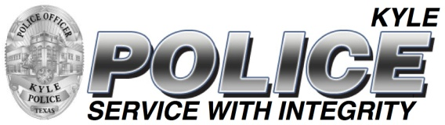
Please return form ASAP to:

Kyle Police Department
Attn: James Plant
PO Box 40
Kyle, Texas 78640
OFFICE Use Only:
Date Received: __________

