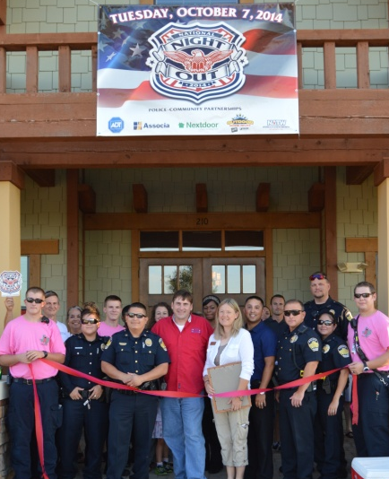
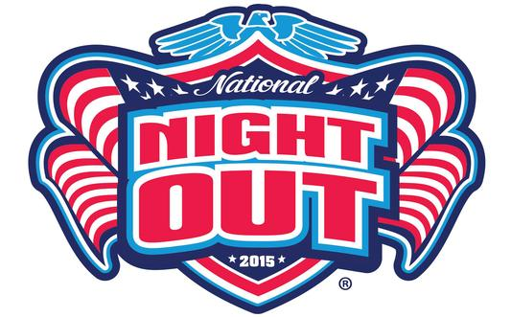

National night Out
Central block party

National Night Out is a community-wide police and fire awareness event held the first Tuesday of October to increase awareness about police programs in the community.

Tuesday, October 6, 2015 at 6pm
Historic City Hall & City Square park

Downtown Kyle residents and residents without a neighborhood party are invited to join the Kyle Police Department and Kyle Police Academy Alumni Association at Historic City Hall and City Square Park for food, fun and entertainment!
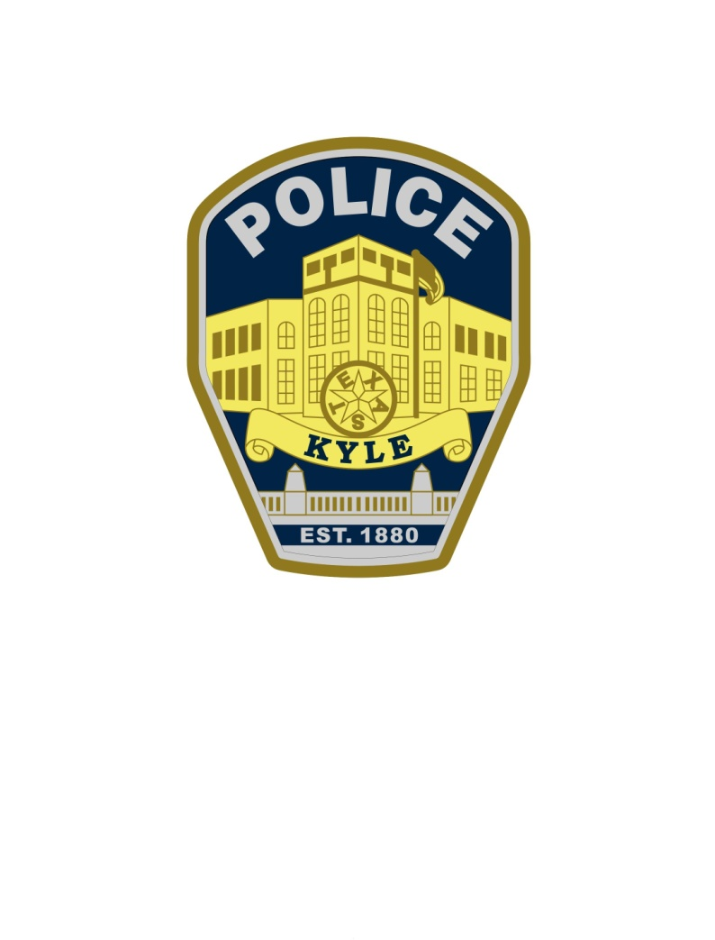
For more information visit
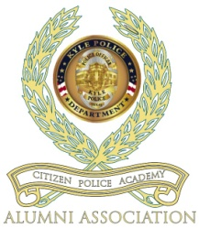
www.cityofkyle.com/police

or

Officer J. Plant
NNO Coordinator
512-262-3996
jplant@cityofkyle.com

