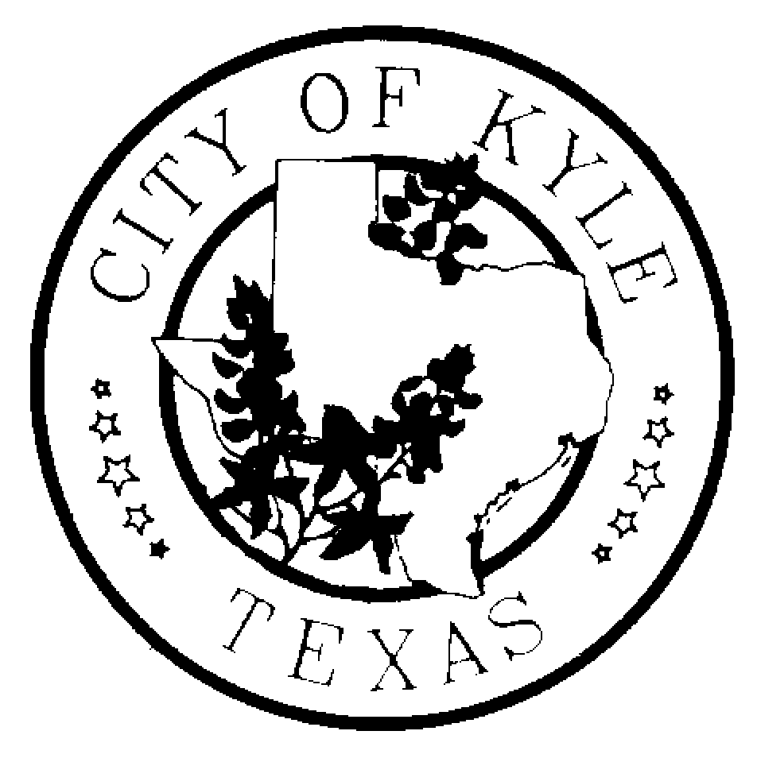
CITY OF KYLE

Notice of Regular Kyle Area Youth Advisory Council (KAYAC) Meeting

Notice is hereby given that the Kyle Area Youth Advisory Council of the City of Kyle, Texas will meet at 7:00pm on Wednesday, the 19th day of February, 2014 at Kyle City Hall
(100 Center St) in Kyle, Texas, in the Council Chambers, for the purpose of discussing the following agenda.
“A quorum of Council Members may attend this Council meeting; however no deliberation or official action of the City Council will be considered at this meeting.”

AGENDA

  - Call to Order
  - Roll Call
  - Public Comments – The Kyle Area Youth Advisory Council welcomes comments from Citizens early in the agenda of regular meetings. Those wishing to speak must sign in before the meeting begins at the Kyle City Hall. Speakers may be provided with an opportunity to speak during this time period, and they must observe the three-minute time limit.

  - Minutes from Previous Meetings: February 5,2014

  - Discussion with Kyle Police Department – E-Cigarette/Vaporizer Research
  - Special Orders
    - Youth Survey - Discussion
    - KAYAC Liaison to serve on Parks and Board
    - Global Youth Service Month (April) – Discussion and possible
recommendation
  - Officer/Committee Reports
    - Economic and Development-Chair- Terrah Friesenhahn
    - Budget Report -Treasurer-Raney Moore
    - City Council Liaison – Nik Fisher
    - Planning and Zoning – James Collins
  - Staff Report
    - Update on KAYAC Members
    - TShirt Order
  - New Business

  - Announcements
    - Annual Plum Creek Watershed Clean Up- March 1, 2014 – 9:30 AM-12:30- Lake
Kyle
    - February 18, 2014- City Council Meeting- former removal and replacement of
members
    - Kyle PARD Jubilee – Saturday, April 26th @ Lake Kyle -Drink Sales? Bounce
House?
    - Teen Night at Kyle Pool – Friday, June 6th – Do we want to plan this?

  - Next Meeting – Wednesday, March 19, 2014

