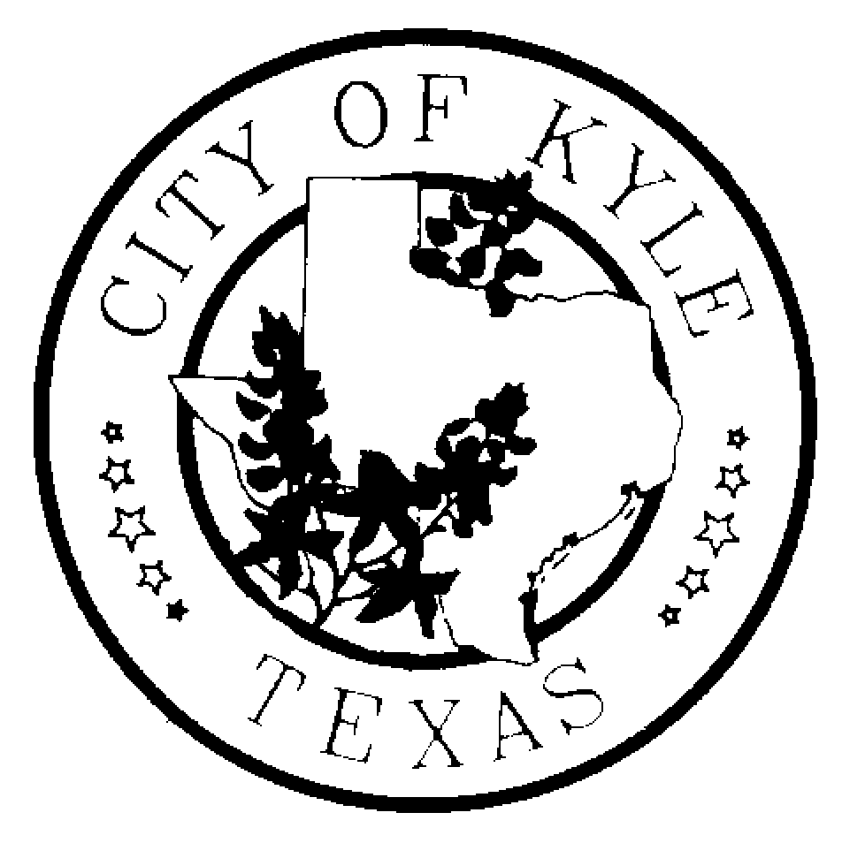
CITY OF KYLE

Notice of Regular Kyle Area Youth Advisory Council (KAYAC) Meeting

Notice is hereby given that the Kyle Area Youth Advisory Council of the City of Kyle, Texas will meet at 6:30pm on Wednesday, the 9th day of March, 2016 at Kyle City Hall (100 W. Center St.) in Kyle, Texas in the Falcon Room, for the purpose of discussing the following agenda.
“A quorum of Council Members may attend this Council meeting; however no deliberation or official action of the City Council will be considered at this meeting.”

AGENDA

  - Call to Order
  - Roll Call
  - Meeting Minutes
  - Public Comments – The Kyle Area Youth Advisory Council welcomes comments from Citizens early in the agenda of regular meetings. Those wishing to speak must sign in before the meeting begins at the Kyle City Hall. Speakers may be provided with an opportunity to speak during this time period, and they must observe the three-minute time limit.
  - Special Orders
    - Discussion on Global Youth Service Day
    - Discussion and action on Easter Eggstravaganza
    - Review of Parks Board Presentations
    - Proposal and discussion on KAYAC Committee Structure
    - Selection and Discussion for Newsletter Subcommittee
  - Reports
    - City Council Liaison – Andy Garza
    - Department Liaison Reports
    - Staff & Treasury Report
  - Requested items for next meeting
  - Announcements/ Reminders
  - Next Meeting – March 23, 2016
  - Adjourn

