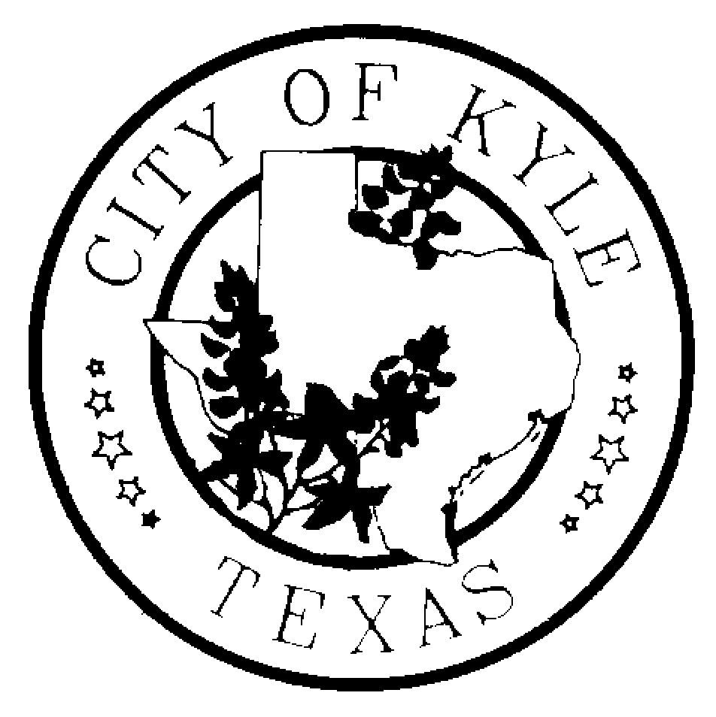
CITY OF KYLE

Notice of Regular Kyle Area Youth Advisory Council (KAYAC) Meeting

Notice is hereby given that the Kyle Area Youth Advisory Council of the City of Kyle, Texas will meet at 6:30pm on Wednesday, the 16th day of November, 2016 at Kyle CIty Hall (100 West Center St) in Kyle, Texas, for the purpose of discussing the following agenda.
“A quorum of Council Members may attend this Council meeting; however no deliberation or official action of the City Council will be considered at this meeting.”

Posted prior to 6:30pm on 11/12/2016

11.16.16 AGENDA

  - Call to Order
  - Roll Call
  - Meeting Minutes
  - Public Comments – The Kyle Area Youth Advisory Council welcomes comments from Citizens early in the agenda of regular meetings. Those wishing to speak must sign in before the meeting begins at the Kyle City Hall. Speakers may be provided with an opportunity to speak during this time period, and they must observe the three-minute time limit.
  - Special Orders
    - Department Liaison Assignment
    - Discussion and Action over Kyle Sidewalk Master Plan
    - Discussion and Action over Police Department Outreach
    - Discussion and Action over KAYAC’s By Laws
    - Discussion over Santa’s Arrival
  - Optional Five Minute Recess
  - Reports
    - Sidewalk Charrette Recap
    - Department Liaison Reports
    - Staff Report -- Nikki Ladet
  - Requested Items for Next Meeting
  - Announcements / Reminders
    - Meet with Department Heads
    - YAC Summit -- February 2017
  - Next Meeting – November 29, 2016 at Kyle City Hall
  - Adjourn

