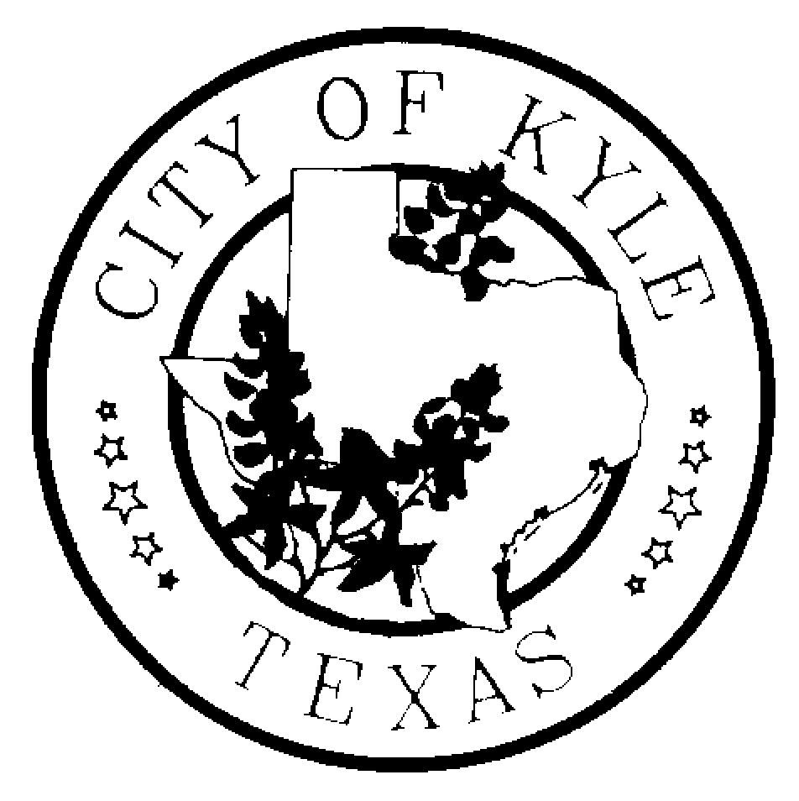
CITY OF KYLE

Notice of Regular Kyle Area Youth Advisory Council (KAYAC) Meeting

Notice is hereby given that the Kyle Area Youth Advisory Council of the City of Kyle, Texas will meet at 6:30pm on Wednesday, the 29th day of November, 2016 at City Hall (upstairs)(100 West Center St) in Kyle, Texas, for the purpose of discussing the following agenda.
“A quorum of Council Members may attend this Council meeting; however no deliberation or official action of the City Council will be considered at this meeting.”

Posted on 11/23/16 before 6:30PM

11.29.16 AGENDA

  - Call to Order
  - Roll Call
  - Meeting Minutes
  - Public Comments – The Kyle Area Youth Advisory Council welcomes comments from Citizens early in the agenda of regular meetings. Those wishing to speak must sign in before the meeting begins at the Kyle City Hall. Speakers may be provided with an opportunity to speak during this time period, and they must observe the three-minute time limit.
  - Special Orders
    - Discussion on Expectations
    - Discussion and Action over Santa’s Arrival
    - Discussion and Action over Kyle Sidewalk Master Plan
    - Discussion and Action over Police Department Outreach
    - Discussion and Action over KAYAC’s By Laws
  - Optional Five Minute Recess
  - Reports
    - Subcommittee Reports
    - Department Liaison Reports
    - Staff Report -- Nikki Ladet
  - Requested Items for Next Meeting
  - Announcements / Reminders
    - Meet with Department Heads
    - YAC Summit -- February 25th - 26th 2017
      - Fill out Emergency Contact Form
    - Santa’s Arrival -- November 30th, 2016
  - Next Meeting – December 7th, 2016 at Kyle City Hall
  - Adjourn

