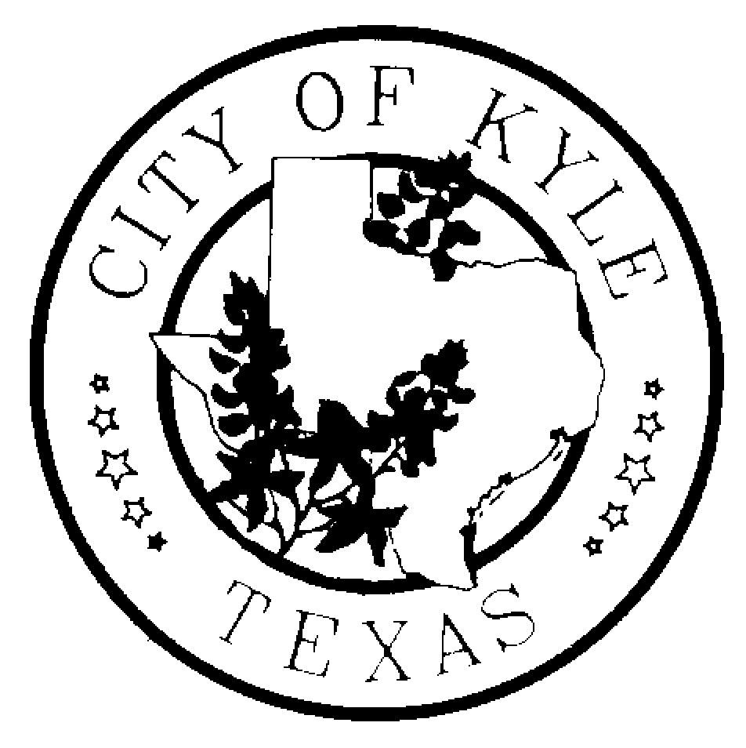
CITY OF KYLE

Notice of Kyle Area Youth Advisory Council (KAYAC) Workshop Meeting

Notice is hereby given that the Kyle Area Youth Advisory Council of the City of Kyle, Texas will meet at 6:30pm on Wednesday, the 11th day of January, 2016 at Kyle CIty Hall (100 West Center St) in Kyle, Texas, for the purpose of discussing the following agenda.
“A quorum of Council Members may attend this Council meeting; however no deliberation or official action of the City Council will be considered at this meeting.”

1.11.17 AGENDA

  - Call to Order
  - Roll Call
  - Meeting Minutes
  - Public Comments – The Kyle Area Youth Advisory Council welcomes comments from Citizens early in the agenda of regular meetings. Those wishing to speak must sign in before the meeting begins at the Kyle City Hall. Speakers may be provided with an opportunity to speak during this time period, and they must observe the three-minute time limit.
  - Special Orders
    - Discussion over Expectations
    - Discussion over Sidewalk Master Plan
  - Reports
    - Staff Report -- Nikki Ladet
  - Requested Items for Next Meeting
  - Announcements / Reminders
    - Get all assignments from this meeting done ASAP
    - YAC Summit -- February 25th - 26th 2017
    - The next meeting is a business meeting
  - Next Meeting – January 25, 2017 at Kyle City Hall
  - Adjourn

