
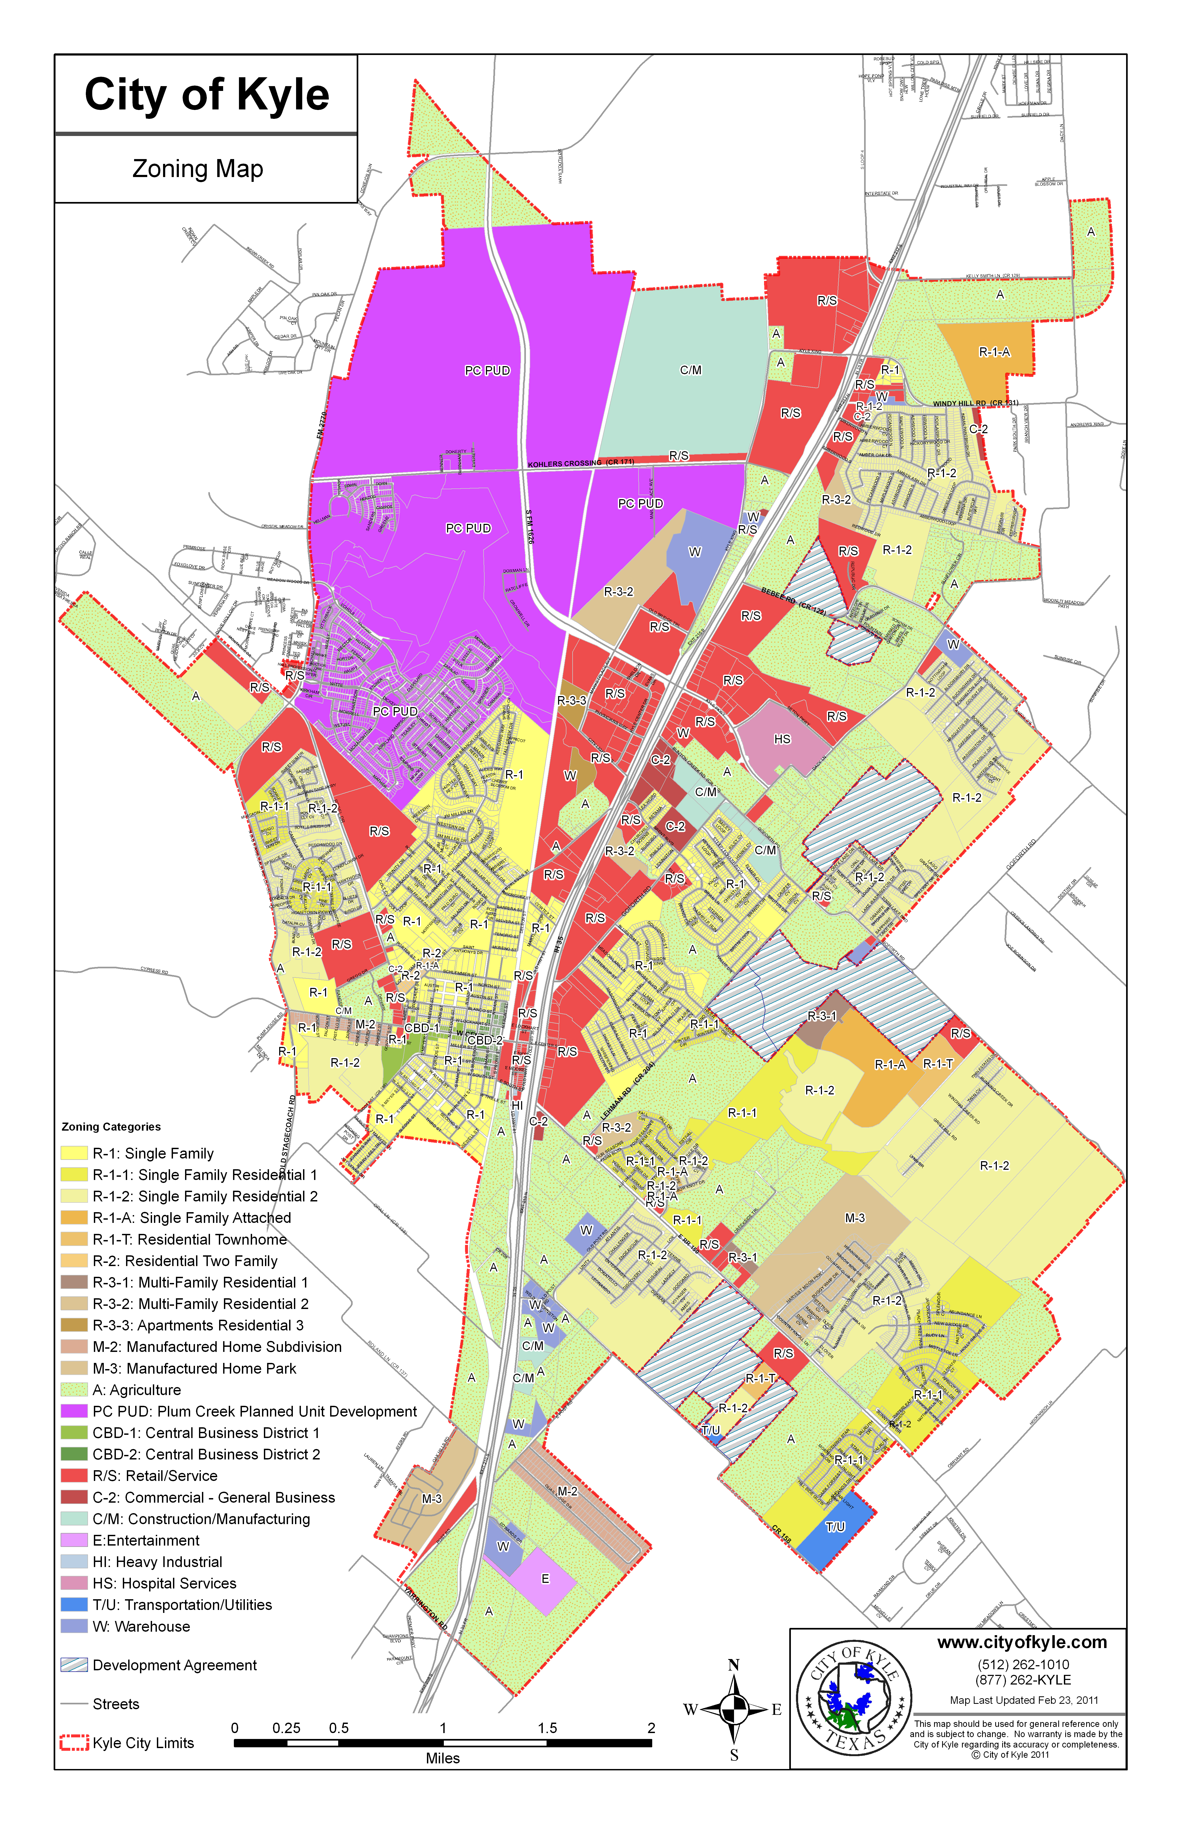
100 W. Center St.
Kyle, TX 78640 USA

(512) 262-1010
(866) 262-KYLE
(512) 262-3987 fax
www.cityofkyle.com

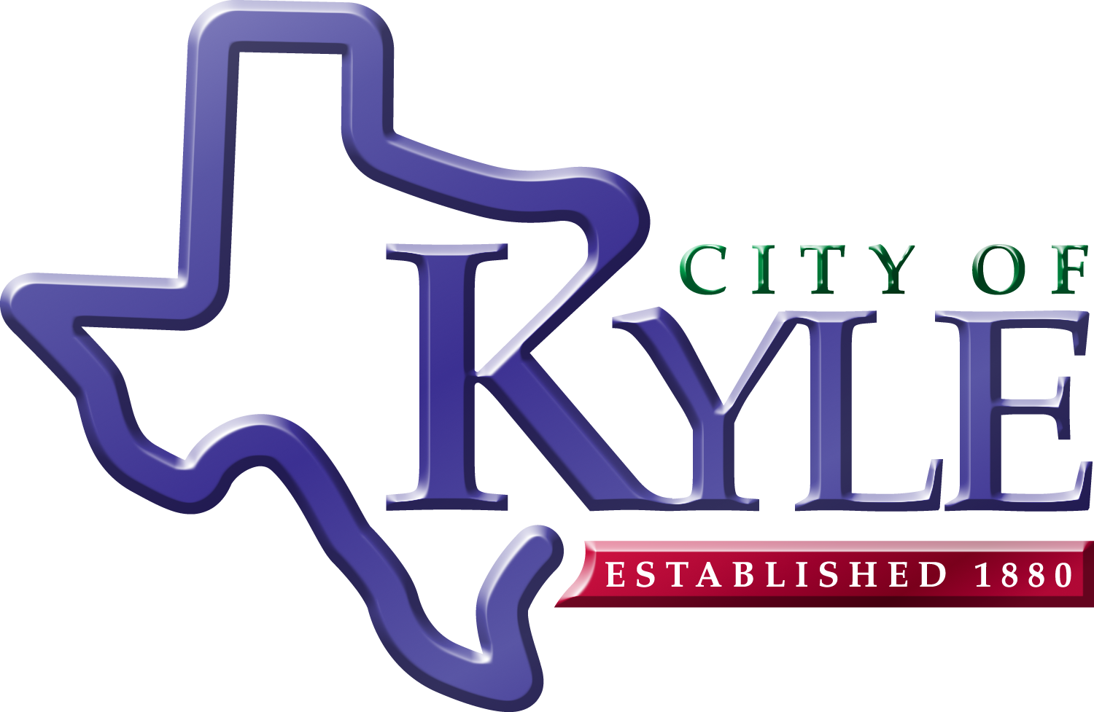
City of Kyle
Zoning Process
Zoning is the basic means of land use regulation. It ensures that land is used in a manner which best serves the health, safety, and welfare of the entire community. This brochure will help you understand how zoning works and the steps needed to zone or rezone property.
 What is my property zoned?

 Can my property be rezoned?

 Can I be guaranteed approval?

 Is it difficult to rezone?

 How do I apply for rezoning?

 What are the steps involved?
 assists in the safe, orderly, healthful and coordinated development of the City.

 conserves existing and future neighborhoods.

 protects and conserves
the value of real property throughout the community.

 conserves, develops, protects, and utilizes natural resources, as appropriate and consistent with the public interest, to enhance the preservation of the environment.

 prevents the over-crowding of land and avoids undue concentration of population or land uses, thereby encouraging high quality development and innovative design.

 lessens congestion in the streets and provides convenient, safe, and efficient circulation of vehicular and pedestrian traffic.

 facilitates the adequate and efficient provision of transportation, water, wastewater, schools, parks, emergency and recreational facilities, and other public requirements.
Zoning…
In this brochure…
City of Kyle
Planning Department
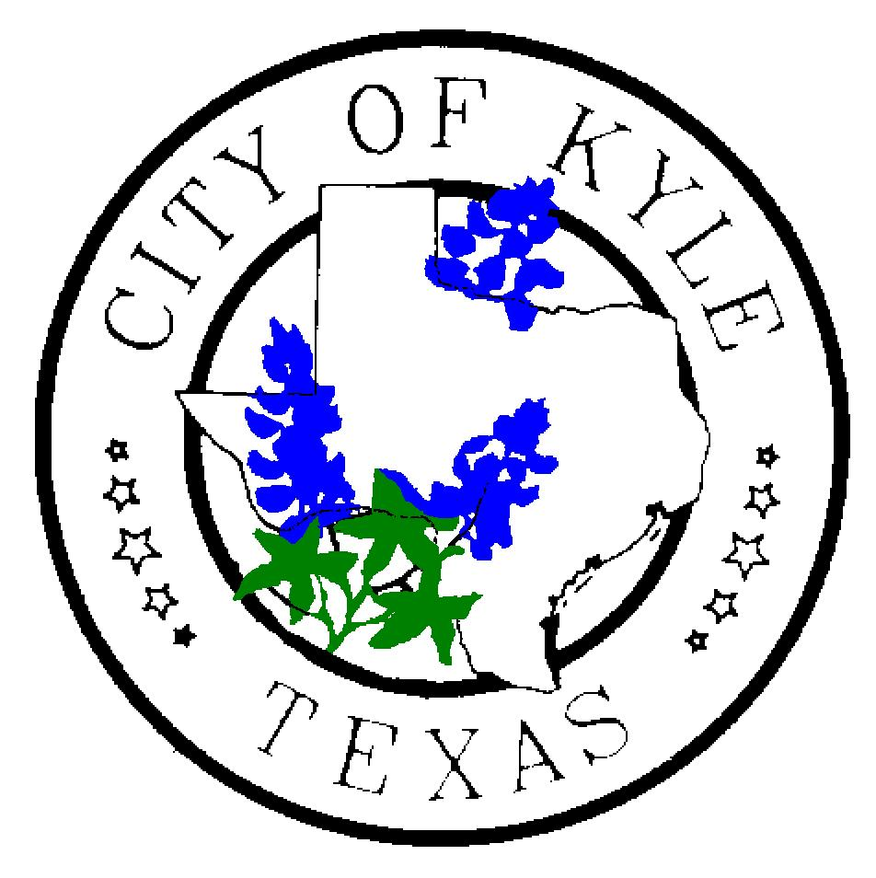
Steps in the Process
Determine current zoning, if any, and what would work best with your intended use.
Submit application with checklist requirements and fees to the Planning Department. (www.cityofkyle.com/planning.php )
Public Notice must be given to surrounding property owners through local newspaper and mail 10 days prior to the Public Hearing.
Your request will go before the Planning and Zoning Commission for a Public Hearing and recommendation to City Council.
The zoning request then goes before City Council for a first reading and public hearing.

The request goes before City Council for a second and final reading.
If approved, you may proceed with your development plans.


Zoning Districts
A – Agriculture
RS – Retail / Services
W -- Warehouse
CM –Construction/Manufacturing
R – Residential
CBD – Central Business District
UE – Urban Estate
M – Manufactured Home
E – Entertainment
TU – Transportation / Utilities
HS – Hospital Services
RV – Recreational Vehicle Park
PUD – Planned Unit Development
H – Historic District (overlay)
CU – Conditional Use (overlay)

 How do I apply for a zoning change?
You can find the necessary forms at
www.cityofkyle.com/planning.php .

 How difficult is it to change my zoning?
It should be emphasized that the rezoning process entails two public hearings that invite input from the community. If your neighbors feel adversely affected by the proposed rezoning, they may protest your request. Before applying for rezoning, contact us to see if your request is consistent with the City’s Future Land Use Map. If it is inconsistent, it is likely that the City will not approve the zoning application unless the future Land Use Map is first amended.

 Is approval guaranteed?
Unfortunately, no. Zoning is a public process that invites input from any interested party. Adjacent property owners or tenants may object to the proposed rezoning. Therefore, land acquisition, based on the hope of rezoning property in the future, does carry some risk.

 What is my property zoned?
You can find the City’s Zoning map at: www.cityofkyle.com
If you need more information, you can call the planning department at 512-262-3925.

