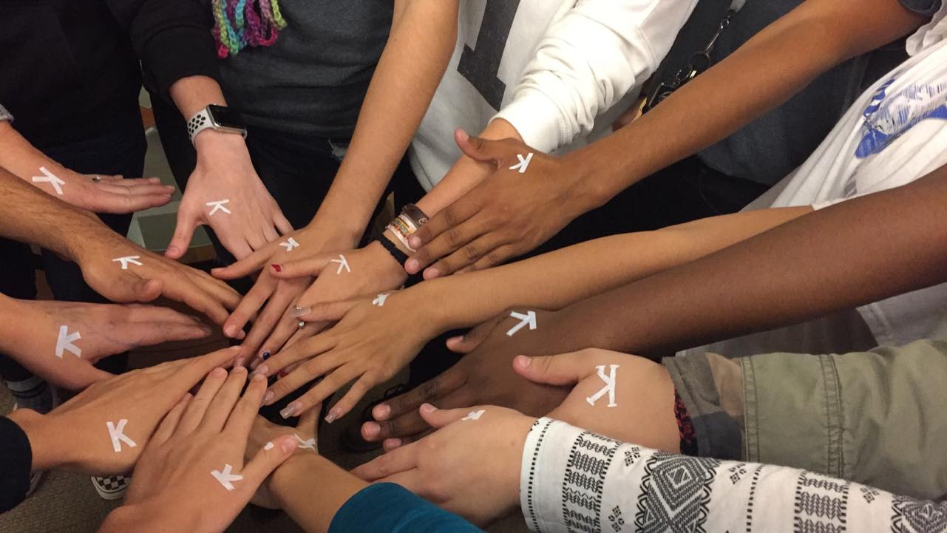
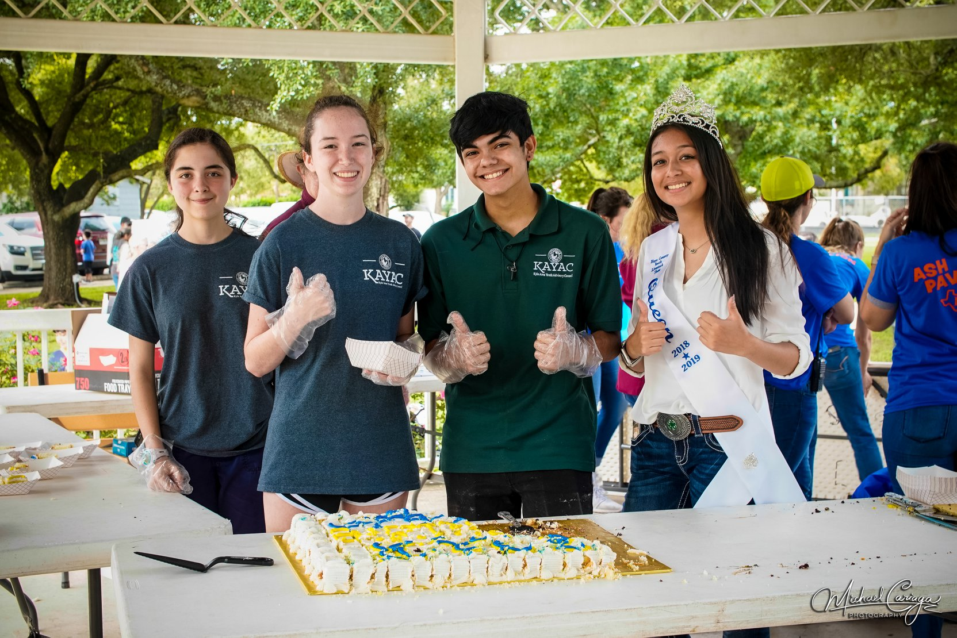
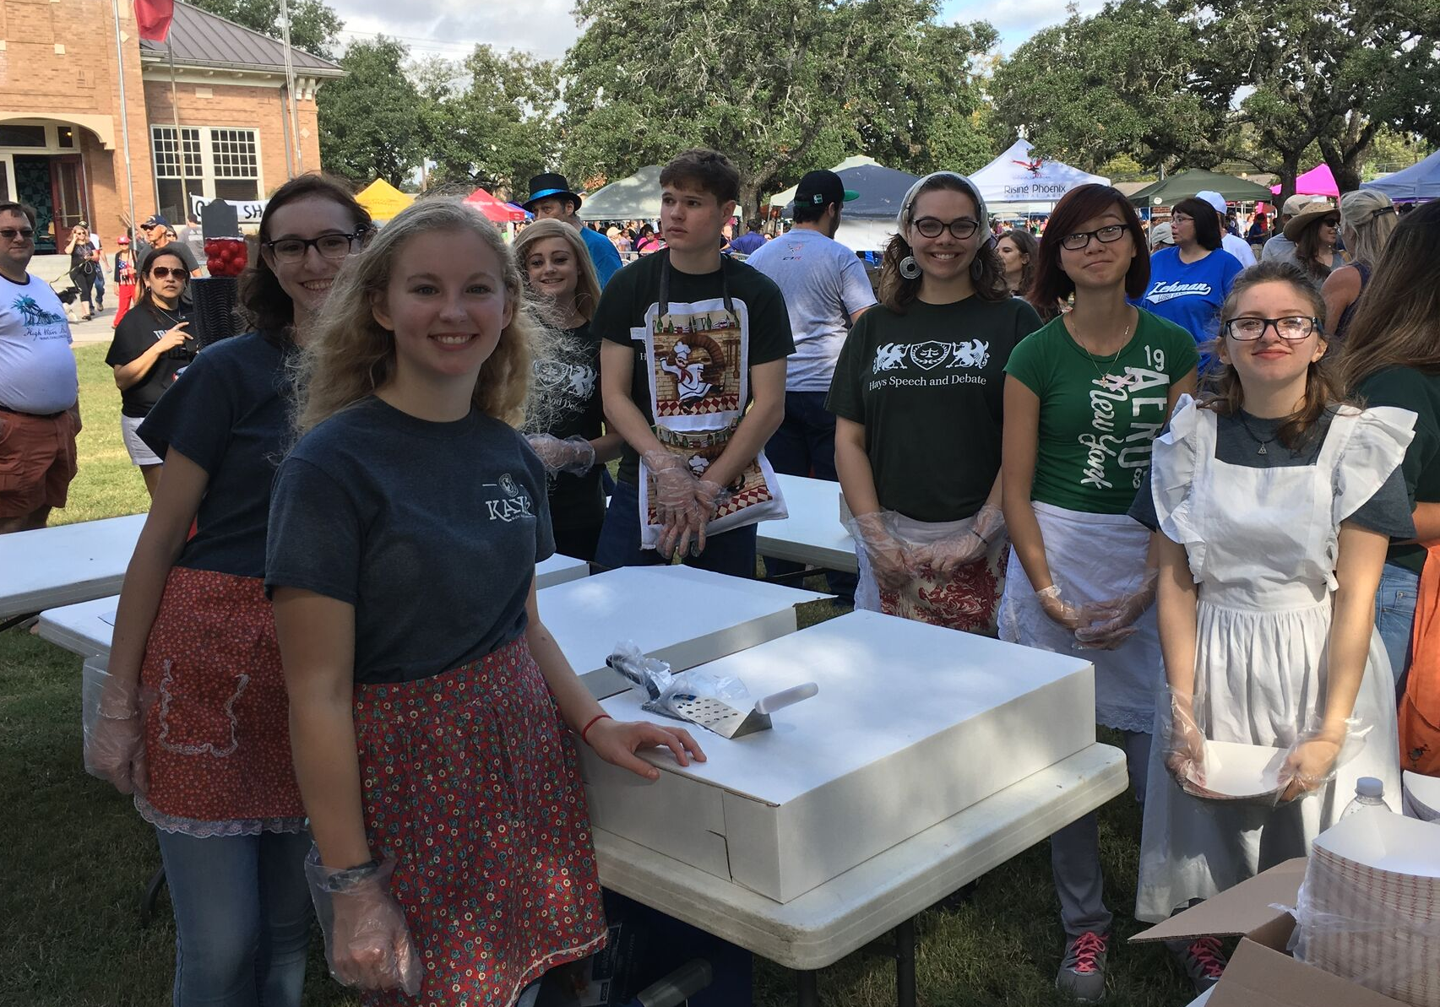
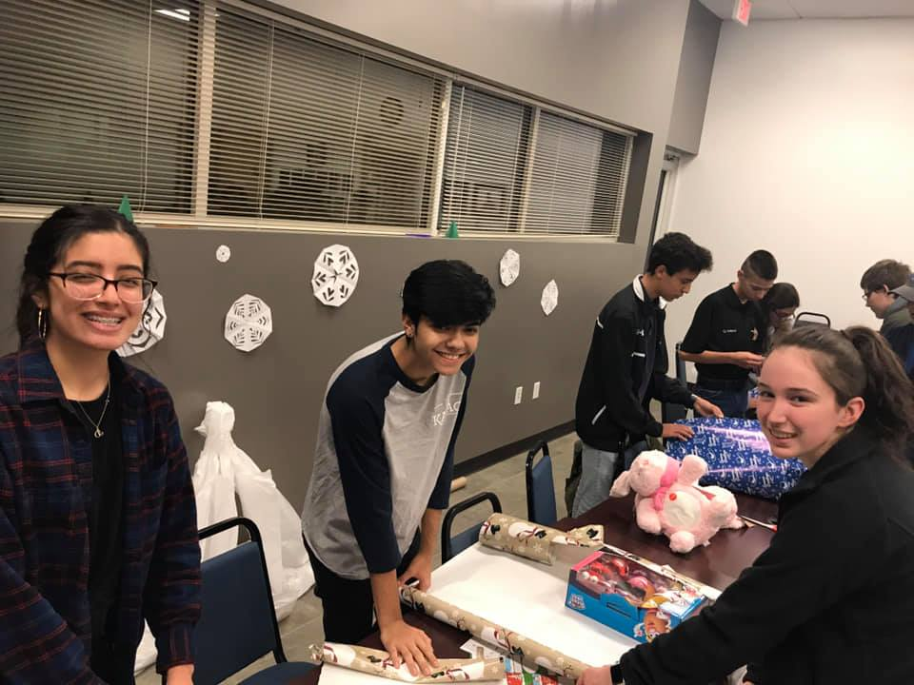

Volunteer Resource Guide
Produced by the
Kyle Area Youth Advisory Council
(KAYAC)

This Volunteer Resource Guide is a product of the Kyle Area Youth Advisory Council (KAYAC). We hope it will provide useful information to those seeking to give of themselves to their community through volunteer service.

To add or update information, contact khilsenbeck@cityofkyle.com.

About KAYAC: The Kyle Area Youth Advisory Council, created by Kyle City Council in 2013, is comprised of high school students who learn about municipal government. Each year they conduct a capstone project of benefit to their community. This guide was the students’ project for the 2018-19 year. To learn more about KAYAC, visit our website: https://www.cityofkyle.com/communications/kyle-area-youth-advisory-council-kayac.

Austin Angels
Description: Support children and their foster families with monthly gifts, relationship-building interactions, and mentoring.
Requirements: A one-year commitment.
Information: 512-312-4500, info@austinangels.com
9901 Brodie Lane
Suite 160 PMB 255
Austin, Texas
www.austinangels.com /

Austin Disaster Relief Network
Description: This network of Christian churches trains volunteers to participate in bringing emotional, physical, and spiritual relief to disaster survivors to help them rebuild their lives and homes.
Requirements: Must wear long pants; hard soled boots and hat required.
Information: 512-428-6322, admin@adrntx.org
1122 East 51st St.,
Austin, Texas 78723
https://adrn.org

AWARE  (Always Wanted a Riding Experience)  Description: Help with care of therapeutic horses, leading horses during instruction, and/or assisting riders in classes. Two-hour orientation provided for new volunteers.  Requirements: N/A  Information: 512-754-6773  1708 Centerpoint Road, San Marcos, Texas |  | 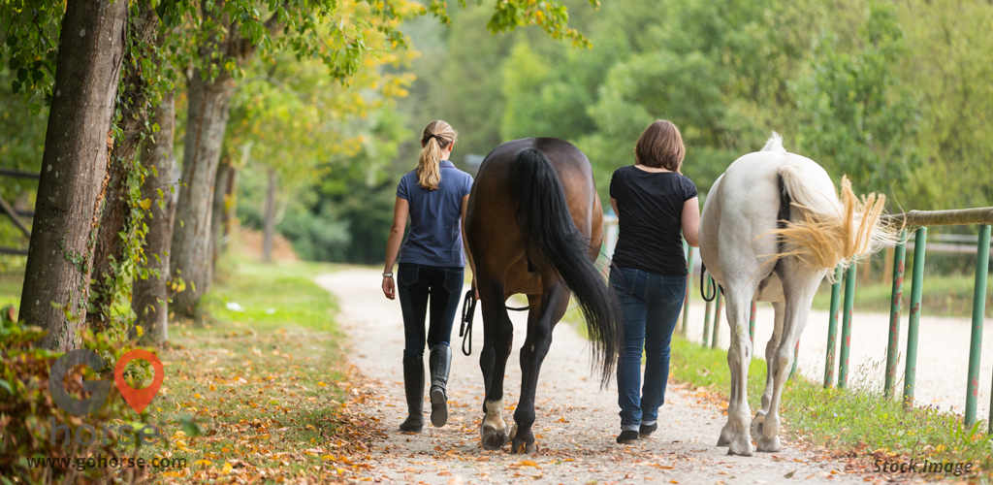

Alzheimer’s Association of Central Texas
Description: Volunteers help to plan and organize events to raise awareness and funds for Alzheimer’s care, support, and research. Two major events are the annual Walk to End All Walks, and The Longest Day at summer’s solstice.
Requirements: N/A
Information: 512-361-5239
5508 Highway 290 West, Suite 206,
Austin, Texas
www.alz.org/texascapital

Communities in Schools of Central Texas  Description: Offers full-time, dedicated social service professionals working year-round on elementary, middle, and high school campuses in Hays CISD. Whether it’s counseling, academic assistance, school supplies, food or positive role models, CIS is there to help students overcome obstacles and return to the classroom ready to learn. CIS empowers students to stay in school and on track to graduate so they can be successful in life.  Requirements: Must complete background check and be at least 18 years old.  Information: 512-464-9767  3000 S. IH 35, Suite 200, Austin, TX 78704  ciscentraltexas.org |  | Buda Public Library  Description: Help with a variety of library activities that may involve books, computers, and people of all ages. Volunteer directly through the library, or with Friends of the Library or the city’s library commission.  Requirements: Fill out and submit application. Must be 13 years or older. No cell phones or mp3 players allowed while volunteering.  Information: 512-295-5899  Buda, TX 78610  www.budalibrary.org

Dreams of Hope Ranch
Description: Help special needs teens and adults reach their potential and achieve desires by helping with day camps, athletic skill building, Special Olympics training, and fundraisers. Volunteers also can help with facilities development and maintenance.
Requirements: N/A
Information: 512-312-9002
16250 Oak Grove Road, Buda, Texas
www.dreamofhopesranch.org

Easter Seals
Description: Volunteers help with special events and fundraisers, clerical duties, camp and the gala committee as well as several other event committees.
Requirements: Under age 18 must be accompanies by a parent or guardian. Must register as an Easter Seals volunteer.
Information: 512-478-2581
Cross Park Dr., Ste. 120
Austin, Texas
http://www.centraltx.easterseals.com/

Hays-Caldwell Women’s Center
Description: Volunteers support the Women’s Shelter by assisting in activities like office work, landscaping, group activities, and more.
Requirements: Volunteers must attend a training session.
Information: 512-396-4357
https://www.hcwc.org/

Helping Hand Home for Children

Description: Volunteers read to children, help with homework, or lead and assist games and activities.

Requirements: Organization accepts volunteer applications two times a year, complete application and background check. Must be a minimum of 18 years of age.
Information: 512-600-6053
3804 Avenue B, Austin, Texas
http://www.helpinghandhome.org

Habitat for Humanity

Description: Volunteers will work as a team to build or repair a home for a family of need in the Central Texas area. Youth volunteers will learn about affordable home opportunities and gain leadership skills.

Requirements: Volunteers of older than 16 and of all abilities are accepted. Must register and have a liability waiver signed if a minor

Information: 512-754-8142
San Marcos P.O. Box 1594, San Marcos
www.habitatforhumanitysanmarcos.org

Hands of Hope
Description: Provides education in subjects including math, English and Bible study, as well as career-readiness training for women of all ages in Hays County. Volunteers can help teach classes, provide child care and serve meals.
Requirements: N/A
Information: 512-618-0723
325 W. McCarty Lane, San Marcos, Texas
www.handsofhopesanmarcos.org

Hays County Food Bank
Description: There are many people in need of food across Hays county, so Hays County Food Bank makes collects and delivers food to those in need.
Requirements: If you are under the age of 18 will require the approval of the parent/guardian in the form of an additional Volunteer Liability Waiver form
Information: 512-392-8300, ext. 222
220 Herndon St., San Marcos, Texas
www.haysfoodbank.org

Hope and Love 4 Kids
Description: Helping children in the Hays County area.
Requirements: N/A.
Information: (512) 585-1726
108 S Burleson St., Kyle, Texas
http://hopeandlove4kids.org

Kyle Public Library
Description: Typical projects include shelving, shelf-reading, book processing, general cleaning of collection items, fixtures and library grounds.
Requirements: Hays County Resident, 17+ unless accompanied by a legal guardian.
Fill out and submit application.
Information: 512-268-7411
550 Scott St, Kyle, Texas
http://www.centraltx.easterseals.com/

Kyle Historic Train Depot
Description: Volunteers assist in giving tours of the depot and providing information to visitors.
Requirements: Volunteers must attend a training session.
Front Street Kyle, Texas
Information: 512-262-3981
www.cityofkyle.com

Marbridge
Description: Marbridge has many opportunities to volunteer for all ages.
Requirements: N/A
Information: 512.282.1144
512.282.3723
PO Box 2250
2310 Bliss Spillar Road
Manchaca, Texas 78652
www.marbridge.org

Meals on Wheels
Description: Volunteers pick-up nutritious meals during lunchtime Monday - Friday and hand-deliver them directly to the homes of seniors and persons with disabilities.
Requirements: Turn in a completed Volunteer Registration Form; a copy of current Driver’s License, a valid inspection sticker, and up-to-date liability insurance coverage on vehicle, as required by the Texas Department of Public Safety. Participate in a MOWCTX volunteer training session and/or view the MOWCTX training video.
Verification checks:
  - Criminal Background History
  - Department of Aging and Disability Services Nurse Aide Registry
  - Department of Aging and Disability Service
  - Employee Misconduct Registry
  - National Sex Offender Registry
Information: 512-476-6325 email@mealsonwheelscentraltexas.org
https://www.mealsonwheelscentraltexas.org

PAWS
Description: Volunteers can help with data entry, dog walking, animal enrichment, photography and more.
Requirements: Submit a PAWS Volunteer Application, which includes signing a Volunteer Agreement and a Release and Waiver of Liability form. Must read handbook and attend orientation. Those age 12-16 must have a parent or guardian present at all times.
Information: 512-268-1611
500 FM 150 East
Kyle, Texas 78640
https://pawsshelter.org/volunteer/

Salvation Army of San Marcos
Description: Serves Hays County in a variety of ways, including providing clothing, housewares, school supplies and emergency response. Volunteer opportunities include ringing the red kettle bell during the holidays and handling clothing at the San Marcos service center.
Requirements: N/A
Information: 512-754-8541
300 CM Allen Parkway, San Marcos, Texas
www.salvationarmytexas.org

San Marcos Greenbelt Alliance
Description: The Alliance is creating an interconnected system of parks and natural areas in and around San Marcos. Volunteers can help with trail work; restoration and natural area monitoring; outreach efforts including social media support and hikes; working with community leaders and landowners; and administrative activities.
Requirements: N/A
Information: 512-392-7457
107 E. Hopkins St., Ste. 123 A,
San Marcos, Texas
www.smgreenbelt.org

San Marcos River Foundation
Description: Volunteer opportunities include helping care for and plant cypress trees on the riverbanks and maintaining a ring of fencing around them to protect the trees from beavers and vandalism. Volunteers can also plant native flora on riverbanks to hold the soil in place and provide food for wildlife. Cleanups of litter in the parks and along tributaries are regularly scheduled and need many volunteers.
Requirements: N/A
Information: 512-787-6392
222 W. San Antonio St.,
San Marcos, Texas
www.sanmarcosriver.org

San Marcos Youth Service Bureau
Description: YSB focuses on service projects, life skills and educational workshops inside the program’s facility and in the community. Volunteers are needed to work alongside youth in activities, demonstrate good citizenship and model positive behaviors as youth are engaged in all aspects of learning and in volunteer work.
Requirements: Ages 11-17.
Information: 512-396-5437
518 S. Guadalupe St.
San Marcos, Texas
www.ysb.org

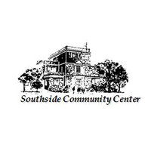 |  | Southside Community Center  Description: helping those in poverty in Hays County since 1927. The organization provides a family homeless shelter and after-school programs for youth and assists those living in poverty with rent and utility bill payments, housing rehabilitation and senior housing. The community center is accepting volunteers for the thrift store and for administrative work at the organization’s office. Volunteers can also serve dinner to those in need. Dinner preparation typically begins at 3 p.m., and dinner is served from 5-7 p.m. daily.  Requirements: N/A  Information: 512-392-6694  518 S. Guadalupe St.  San Marcos, Texas  www.southsidecommunitycenter.org

Women of Unity
Description: A nonprofit organization of women that work to do great things in the community. For the “Be a Blessing” project, in which they provide gifts/toys to families with children that have special needs, volunteers can pass out flyers, collect toys/gifts, and gather family such as address, ages, contact number, and any special wishes.
Requirements: N/A
Information: 512-749-6071
P.O Box 2733
Kyle, Texas
womenofunity2015@yahoo.com

Seasonal / Event Opportunities
Pie in the Sky Hot Air Balloon Festival
Description: A hot air balloon festival taking place each
Labor Day weekend in Kyle, Texas. Volunteers help with
vendors, balloonists, ticketing, parking and kids zone.
Requirements: Must be in ninth grade or older.
Information: Email Kathy or Lauren,
kroecker@cityofkyle.com or llyons@cityofkyle.com
www.kyletxpieinthesky.com
Kyle Blue Santa
Description: Kyle Police Employees Association,
in conjunction with the Kyle Citizens Police Academy
Alumni Association, collect new toys and monetary
donations to purchase bikes. They then wrap and distribute
the gifts to local children in need.
Requirements: N/A
Information: contact@kpea.us
https://m.kpea.us/Blue-Santa.html

