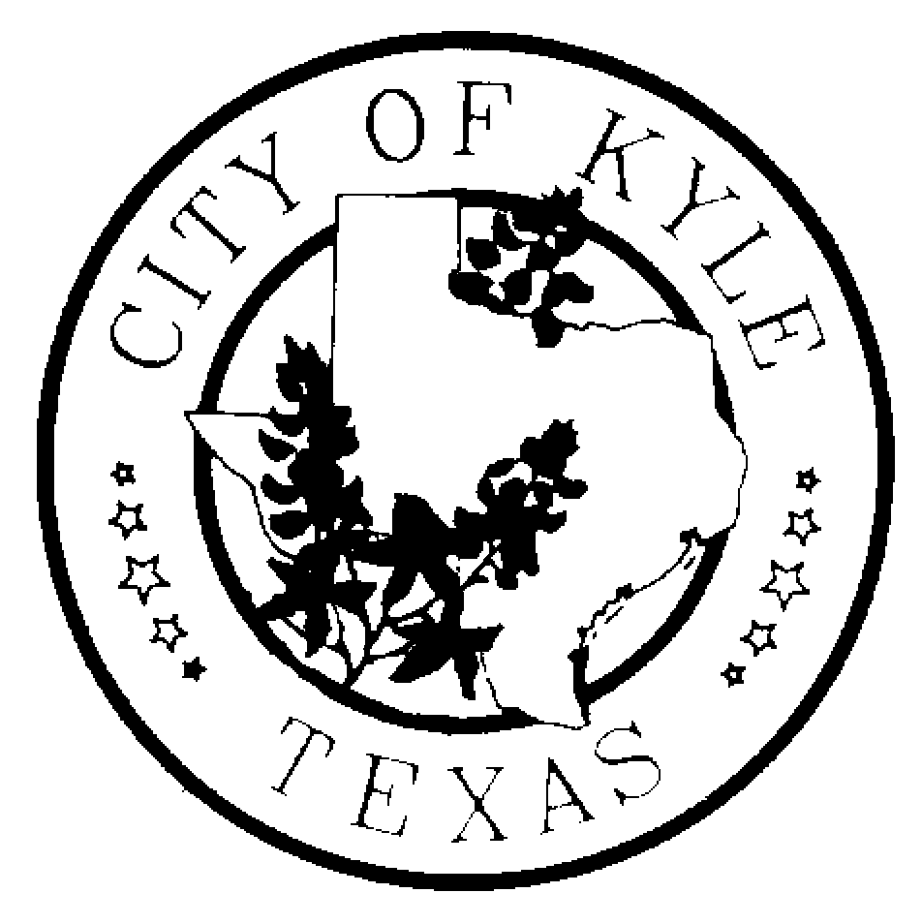

Economic Development and Tourism Committee
City of Kyle

Agenda
January 10, 2013~6:30 pm~ Kyle City Hall

- Call to Order

- Approval of Minutes
  - August 9, 2012
  - November 15, 2012

- Citizens Comment Period

- Discussion/Possible Recommendation regarding two Economic Development Committee member vacancies

- Discussion/Update regarding proposed Roadway Bond Election

- Discussion regarding potential for future economic development funding

- Additional Topics to Discuss?
  - Update on Proposed LSTAR

- Economic Development Update
  - I35 Overlay Update
  - City Manager 2013 Goals
  - Sales Tax and Building Permit Activity Report
  - Project Update –Confidential

- Adjourn

*The Economic Development and Tourism Committee is an advisory body to the City Council with no power to make final decisions or adopt rules regarding public business. The ED&T Committee may convene into executive session, as needed, on any item listed on the agenda.

