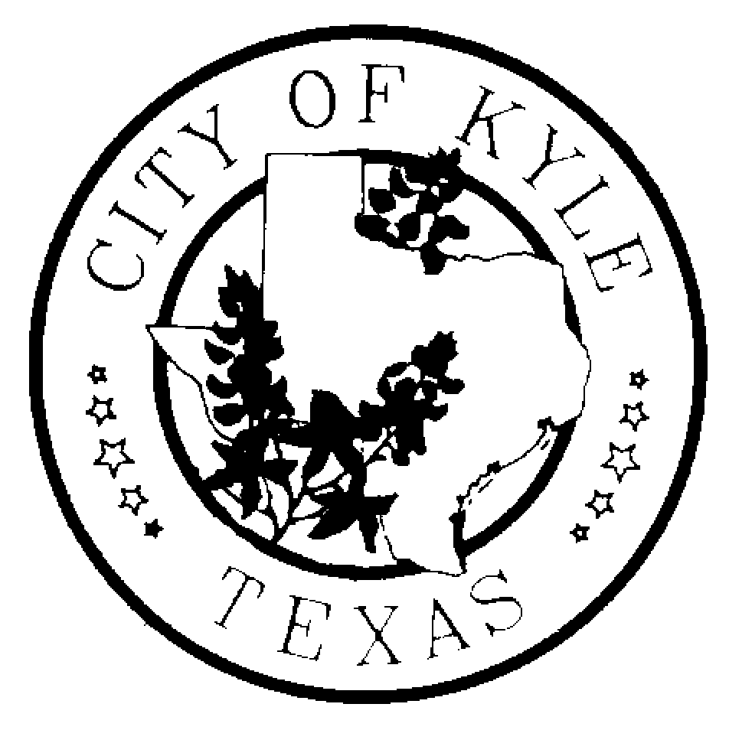

Economic Development and Tourism Committee
City of Kyle
Special Meeting

Agenda
June 3, 2013~6:30 pm~ Kyle City Hall

- Call to Order

- Citizens Comment Period

- Convene into Executive Session pursuant to Section 551.087, Tex. Gov't Code, to deliberate offers of financial or other incentives to and economic development negotiations with business prospects that the City seeks to have locate, stay, or expand in or near the City, (Project Fern)

- Reconvene into Open Session to and take any and all action and make any recommendations as deemed appropriate in the Economic Development & Tourism Committee’s discretion regarding offers of financial or other incentives and economic development negotiations with business prospects that the City seeks to have locate, stay or expand in or near the City, (Project Fern)

- Adjourn

*The Economic Development and Tourism Committee is an advisory body to the City Council with no power to make final decisions or adopt rules regarding public business. The ED&T Committee may convene into executive session, as needed, on any item listed on the agenda.

