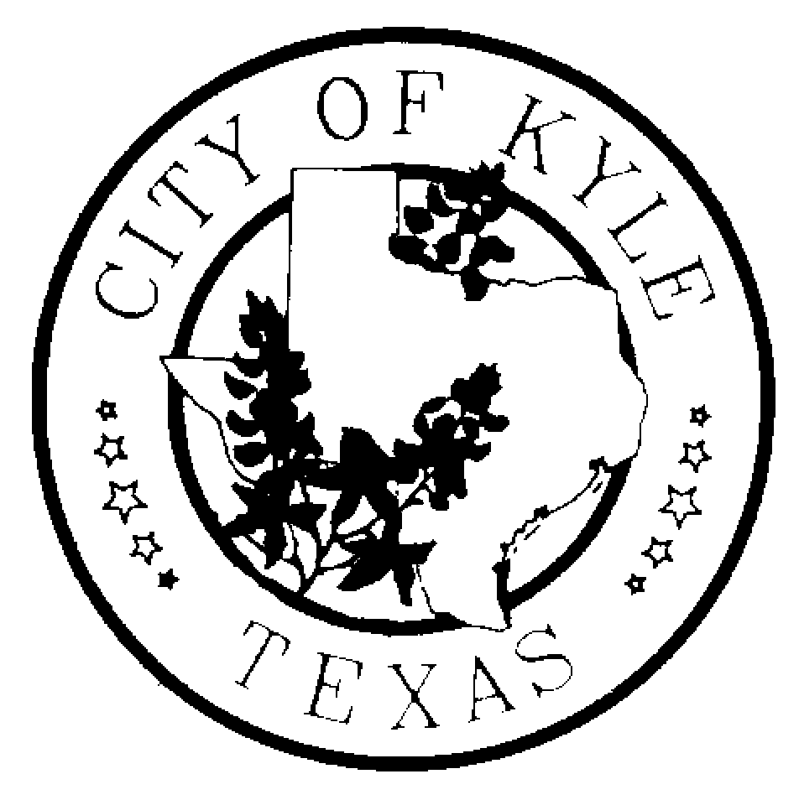

Economic Development and Tourism Committee
Retreat
City of Kyle

Agenda
June 14, 2013~9:00 am- 1:00pm
Kyle Police Department Briefing Room
111 N. Front Street

- Call to Order

- Citizens Comment Period

- Discussion of Economic Development & Tourism Committee 2013 goals.

- Adjourn

*The Economic Development and Tourism Committee is an advisory body to the City Council with no power to make final decisions or adopt rules regarding public business. The ED&T Committee may convene into executive session, as needed, on any item listed on the agenda.

NOTE: There may be a quorum of the City Council, Planning & Zoning and Board of Adjustments of Kyle, Texas present at the meeting who may participate in the discussion. No official action will be taken by the members in attendance.

