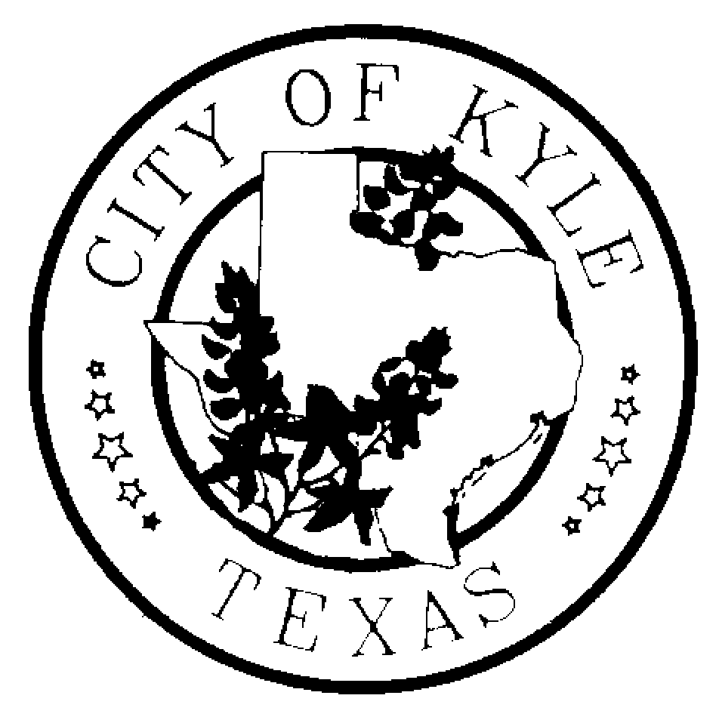

Economic Development and Tourism Committee
City of Kyle

Agenda
September 16, 2013~6:30 pm~ Kyle City Hall

- Call to Order

- Approval of Minutes
  - July 18, 2013
  - August 8, 2013

- Citizens Comment Period

- Discussion/Possible Recommendation regarding Economic Development and Tourism Committee vacancies

- Discussion/Possible Action on ED&T Committee Work Plan

- Additional Topics to Discuss?

- Economic Development Update
  - Sales Tax and Building Permit Activity Report
  - Project Update –Confidential

- Adjourn

*The Economic Development and Tourism Committee is an advisory body to the City Council with no power to make final decisions or adopt rules regarding public business. The ED&T Committee may convene into executive session, as needed, on any item listed on the agenda.

