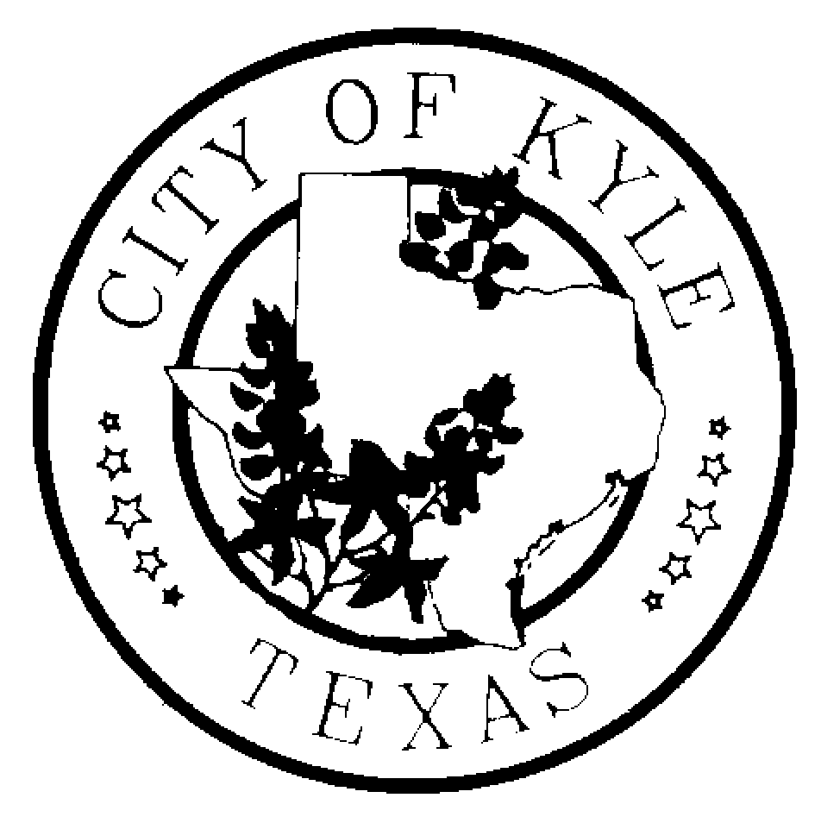

Economic Development and Tourism Committee
City of Kyle

Agenda
January 9, 2014~6:30 pm~ Kyle City Hall

- Call to Order

- Approval of Minutes
  - December 12, 2013

- Citizens Comment Period

- Consideration and Possible Recommendation regarding proposed PCD Development 380 agreement.

- Additional Topics to Discuss?

- Executive Session
  - Convene into Executive Session pursuant to Section 551.087, Tex. Gov’t Code, to deliberate offers of financial or other incentives and economic development negotiations with business prospects that the City seeks to have locate, stay or expand in or near the City, (PCD Development)

  - Reconvene into Open Session to take any and all actions as deemed appropriate regarding offers of financial or other incentives and economic development negotiations with business prospects that the city seeks to have locate, stay or expand in or near the City, (PCD Development)

- Economic Development Update
  - Sales Tax and Building Permit Activity Report
  - Project Update –Confidential

- Adjourn

*The Economic Development and Tourism Committee is an advisory body to the City Council with no power to make final decisions or adopt rules regarding public business. The ED&T Committee may convene into executive session, as needed, on any item listed on the agenda.

