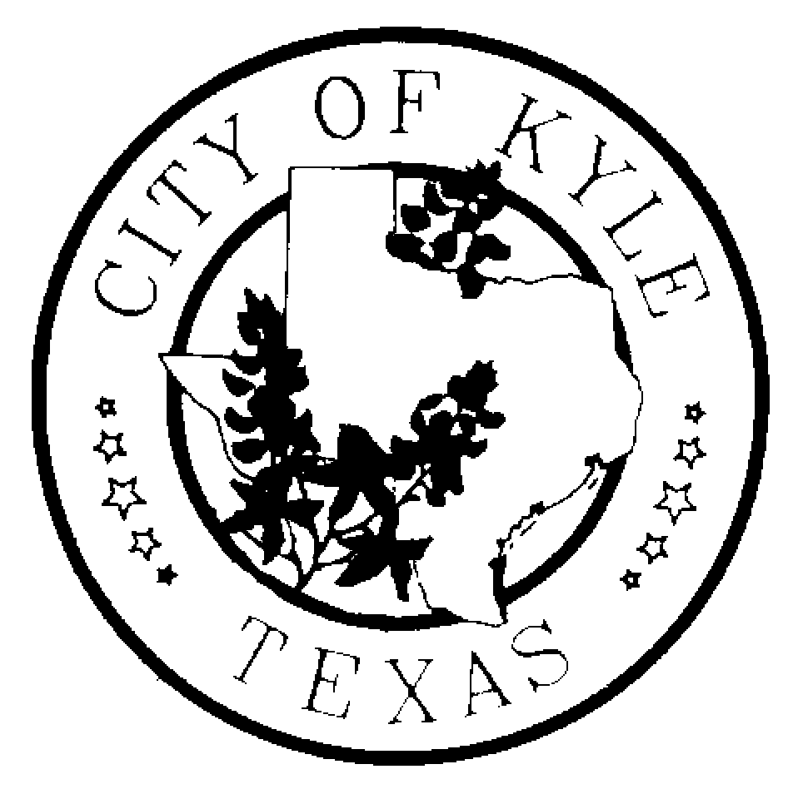

Economic Development and Tourism Committee
City of Kyle

Workshop
Agenda
January 9, 2014~4:30 pm~ Kyle City Hall

- Call to Order

- Consideration and Possible Recommendation
Educational presentation and discussion of economic development concepts, policies and procedures that impact the Economic Development and Tourism committee.

- Adjourn

*The Economic Development and Tourism Committee is an advisory body to the City Council with no power to make final decisions or adopt rules regarding public business. The ED&T Committee may convene into executive session, as needed, on any item listed on the agenda.

