ARTICLE V. - LANDSCAPING, SCREENING, AND OUTDOOR LIGHTING^{[4]}
Footnotes:
--- (4) ---
Editor's note— 909 , § 1(Exh. A), adopted Aug. 17, 2016, amended the title of art. V from "Landscaping and Screening Requirements" to read as herein set out. Inasmuch as said ordinance enacted new provisions to art. V regulating outdoor lighting, and for purposes of clarity and organization, the existing §§ 53-984—53-995 have been redesignated div. 1, landscaping and screening requirements, with the additional provisions designated div. 2, outdoor lighting regulations.

DIVISION 1. - LANDSCAPING AND SCREENING REQUIREMENTS

Sec. 53-984. - Purpose.
The purpose of this article is, in conjunction with the other requirements of this chapter, to promote and support the orderly, safe, attractive and healthful development of land located within the community, and to promote the general welfare of the community by preserving and enhancing ecological, environmental and aesthetic qualities, through established requirements for the installation and maintenance of landscaping elements and other means of site improvements in developed properties. The following are additional factors considered in establishing the requirements of this article:
(1) Paved surfaces, automobiles, buildings and other improvements produce increases in air temperatures, a problem especially noticeable in this southern region, whereas plants have the opposite effect through transpiration and the creation of shade. Likewise, impervious surfaces created by development generate greater water runoff causing problems from contamination, erosion and flooding. Preserving and improving the natural environment and maintaining a working ecological balance are of increasing concern. The fact that the use of landscape elements can contribute to the processes of air purification, oxygen regeneration, water absorption, water purification, and noise, glare and heat abatement as well as the preservation of the community's aesthetic qualities indicates that the use of landscape elements is of benefit to the health, welfare and general well-being of the community and, therefore, it is proper that the use of such elements be required.
(2) The city experiences frequent droughts and periodic shortages of adequate water supply; therefore, it is the purpose of this article to require the use of drought resistant vegetation that does not consume large quantities of water. (See section 53-1231, grow green plant guide for native and adapted landscape plants.)
(Ord. No. 438, § 61(a), 11-24-2003)
Sec. 53-985. - Installation and plan.
(a) All applications for a development permit must be accompanied by a landscape plan prepared and sealed by a registered landscape architect, certified arborist, or registered forester, except for developments in the A, UE, R-1-1, R-1-2 and R-1-A districts.
(b) All landscape plans shall be prepared and sealed by a registered landscape architect, certified arborist, or registered forester.
(c) All landscape materials shall be installed according to ANSI A300 standards.
(d) Replacement of trees in the minimum required landscape areas, as determined by this section, must occur under the following conditions:
(1) To establish the minimum tree density requirements for the site.
(2) Where grading occurs outside the buildable area of the lot.
(3) Where specimen trees or specimen stands of trees within the buildable portion of the lot are to be removed.
(4) Where specimen trees or specimen stands of trees, and trees within otherwise designated tree protective zones have been irreparably damaged or removed through development or construction activities.
(Ord. No. 438, § 61(b), 11-24-2003; Ord. No. 912 , § 1(Exh. A), 10-18-2016)
Sec. 53-986. - Maintenance.
(a) The owner of the landscaped property shall be responsible for the maintenance of all landscape areas. Said areas shall be maintained so as to present a healthy, neat and orderly appearance at all times and shall be kept free of refuse and debris. All planted areas shall be provided with a readily available water supply and watered as necessary to ensure continuous healthy growth and development. Maintenance shall include the replacement of all dead plant material if that material was used to meet the requirements of this article. Landscape material must be trimmed and maintained for roadway visibility.
(b) All property within the city limits will adhere to city drought management program when watering.
(Ord. No. 438, § 61(c), 11-24-2003; Ord. No. 912 , § 1(Exh. A), 10-18-2016)
Sec. 53-987. - Planting criteria.
(a) Trees. Trees shall be a minimum of three inches in caliper measured six inches above the root flare immediately after planting. A list of recommended landscape trees may be obtained from the city. If the developer chooses to substitute trees not included on the recommended list, those trees shall have an average mature crown greater than 15 feet in diameter to meet the requirements of this article. Trees having an average mature crown less than 15 feet in diameter may be substituted by grouping trees so as to create at maturity the equivalent of a 15-foot diameter crown if the drip line area is maintained. A minimum area three feet in radius is required around the trunks of all existing and proposed trees.
(b) Tree selection.
(1) Trees selected for planting must meet minimum requirements as provided below and in the American Standard of Nursery Stock.
(2) Trees selected for planting must be free from injury, pests, disease, or nutritional disorders.
(3) Trees selected for planting must be of good vigor. The determination of vigor is a subjective evaluation, and dependent upon species variability. The following criteria is generally used for the determination of vigor:
a. Foliage should have a green or dark green color. Vigorous trees will have large leaves and dense foliage when compared to trees with poor vigor.
b. Shoot growth for most vigorous trees will be at least one foot per year. At least one-half of the branches should arise from the top one-third and one-half from the center one-third.
c. Bark texture can denote vigor. Smooth or shiny bark on the trunk and branches of a young tree usually signifies good vigor; conversely, rough and dull bark could indicate poor vigor.
d. Trunk taper. The trunks of vigorous trees will generally have an increase in diameter with a decrease in height. Trees with reverse tapers or no taper should be avoided.
e. Root color. Young roots of most trees will be light in color.
(4) Trees selected for planting must be free of root defects. Two types of root defects generally occur:
a. Kinked roots, in which taproots, major branch roots, or both are bent more than 90 degrees with less than 20 percent of the root system originating above the kink. A tree with such roots will probably bend at the soil line when released from a supporting stake.
b. Circling or girdling roots which circle 80 percent or more of the root system by 360 degrees or more. A tree with such roots would ultimately have less than 20 percent of its system available for support.
(c) Shrubs and ground cover. Shrubs, vines and ground cover planted pursuant to this section shall be good, healthy nursery stock. Shrubs must be, at a minimum, a one-gallon container size, but shall average two-gallon for the entire project, and be drought resistant species. This applies to all zoning classifications.
(d) Turf grass. In order to limit the volume of water required for the turf, it is required that grass areas be planted with drought resistant species normally grown as permanent lawns, such as Bermuda, Zoysia, Buffalo or other similar drought resistant grasses. Grass areas may be sodded, plugged, sprigged or seeded except that solid sod shall be used in areas subject to erosion. This applies to all zoning classifications.
(1) Other low water requirement turf products will be considered and may be approved by a designated city official or body on a case-by-case basis.
(2) These requirements for specific types of turf are adopted to establish conservation practices under the drought management plan of the city.
(3) The requirements set forth in this subsection shall not prohibit the installation or planting of any turf not described in this section (nonconforming turf) if at least 50 percent of the nonimpervious cover area of the lot or parcel was planted with a nonconforming turf prior to the effective date of the ordinance from which this chapter is derived and the same nonconforming turf is being installed or planted.
(e) Synthetic plants. Synthetic or artificial lawns or plants shall not be used in lieu of plant requirements in this section.
(f) Architectural planters. The director of planning and community development or his/her designee is authorized to approve the use of architectural planters when he/she determines the overall intent of the division and/or specific guidelines can be met.
(g) Other. Approved decorative aggregate or pervious brick pavers shall qualify for landscaping credit if contained in planting areas, but no credit shall be given for concrete or other impervious surfaces. No more than 50 percent of the required total landscape area may covered in aggregate and/or pervious pavers.
(Ord. No. 438, § 61(d), 11-24-2003; Ord. No. 912 , § 1(Exh. A), 10-18-2016)
Sec. 53-988. - Landscaping requirements.
A minimum percentage of the total lot area shall be devoted to landscape development in accordance with the following schedule:
Zoning and/or Proposed Land Use | Percentage
R-1-T, R-1-C, R-3-1, R-3-2, R-3-3, CBD-1 | 15
R-1-1, R-1-2, R-1-A, R-2, M-1, M-2, M-3 | Note 1
CBD-2, RS, E, TU (SIC code 48811900 only), CC, RV | 10
W, CM | 15
PUD | Note 2
Agricultural, E | None
Private and public park/public area | 20

Note 1—Minimum landscape requirements for each lot on which a single-family, duplex, triplex or fourplex dwelling, or a manufactured home, is constructed or installed after the date of the ordinance from which this chapter is derived shall be a minimum of two three-inch trees, six two-gallon shrubs and lawn grass from the front property line to the front two corners of the structure all plants shall be of native and adapted species and drought resistant. Residential structures on reverse frontage lots shall also be required to screen the rear of the structure from the abutting highway, access road, or other public rights-of-way.
Note 2—Landscaping requirements will apply to planned unit developments in the same manner as the requirements listed in note 1, to be determined by the zoning classification assigned to the planned unit development.
(Ord. No. 438, § 61(e), 11-24-2003; Ord. No. 912 , § 1(Exh. A), 10-18-2016)
Sec. 53-989. - Exceptions.
(a) In order to address atypical, site-specific development/redevelopment challenges, the director of planning and community development and/or his/her designee, following ten days of on-site notification of an applicant's request, is authorized to approve alternative compliance landscape plans when s/he determines that one or more of the following conditions are present:
(1) The site has space limitations or an unusual shape that makes strict compliance impossible or impractical;
(2) Conditions on or adjacent to the site such as topography, soils, vegetation or existing structures or utilities are such that strict compliance is impossible, impractical or of no value in terms of advancing the general purposes of this division;
(3) Safety considerations such as intersection visibility, utility locations, etc., make alternative compliance necessary; or
(4) Creative, alternative landscape plans will provide an equal or better means of meeting the intent of the landscaping and screening regulations of this division.
(b) Those parties with standing, aggrieved by that decision of the director or his/her designee for alternate method(s) of compliance described in this section, may appeal the decision to the planning commission if the appeal request is made within 30 days of the decision being issued. At the subsequent hearing, the planning commission can affirm the staff decision, reverse and/or remand the staff decision, or modify the decision to any standard approved as appropriate by the commission.
(Ord. No. 438, § 61(f), 11-24-2003; Ord. No. 912 , § 1(Exh. A), 10-18-2016)
Sec. 53-990. - Placement.
Landscaping shall be placed upon that portion of a tract or lot that is being developed. A minimum 35 percent of the required landscaped area and required plantings shall be installed between the front property lines and the building being constructed, unless a lesser percentage is approved by planning staff. Undeveloped portions of a tract or lot shall not be considered landscaped, except as specifically approved by the planning and zoning commission. Landscaping placed within public rights-of-way shall not be credited to the minimum landscape requirements by this article.
(Ord. No. 438, § 61(g), 11-24-2003; Ord. No. 912 , § 1(Exh. A), 10-18-2016)
Sec. 53-991. - Credit.
The director of planning and community development or his/her designee shall, with respect to the issuance of a building permit or approval of a construction or site development plan, give a credit against the requirements of this article for trees preserved on the site; provided that, in order to reward the preservation of significant tees, a credit may be given for such preservation only if no more than 30 percent of the critical root zone is disturbed or distressed with impervious cover.
(Ord. No. 438, § 61(h), 11-24-2003; Ord. No. 912 , § 1(Exh. A), 10-18-2016)
Sec. 53-992. - Additional required plantings.
(a) For every 600 square feet of landscape area required by this article, two trees and four shrubs shall be planted. To reduce the thermal impact of unshaded parking lots, additional trees shall be planted, if necessary, so that no parking space is more than 50 feet away from the trunk of a tree, unless otherwise approved by the planning and zoning commission. This section shall not apply to any property included in any of the following zoning categories: A, R-1-1, R-1-2, R-1-A, C/M, or W.
(b) For all nonresidential properties except agriculture and planned unit developments (PUDs), or residential properties larger than one acre, the following scale of required planting shall apply:
(1) Case 1: Required landscape area— less than 10,000 square feet = One three-inch caliper tree and three one-gallon shrubs per 1,000 square feet (maximum ten trees and 30 shrubs).
(2) Case 2: Required landscape area— between 10,000 square feet and 110,000 square feet = Ten three-inch caliper trees and 30 one-gallon shrubs (maximum 50 trees and 30 shrubs).
(3) Case 3: Required landscape area— greater than 110,000 square feet = 50 three-inch caliper trees and 30 one-gallon shrubs plus one three-inch caliper tree per 10,000 square feet.
(4) Planting option— Four four-inch trees or three four-inch to five-inch trees count as credit for five three-inch trees.
If more than 30 trees will be used, a mixture of three or more tree species must be used. If more than 50 shrubs will be used, a mixture of three or more shrub species must be used.
(Ord. No. 438, § 61(i), 11-24-2003; Ord. No. 912 , § 1(Exh. A), 10-18-2016)
Sec. 53-993. - Replacement of required trees.
Upon the death or removal of a tree planted pursuant to the terms of this article, a replacement tree of equal size and type shall be required to be planted. A smaller tree that will have a mature crown similar to the tree removed may be substituted if the planting area or pervious cover provided for the larger tree in this article is retained.
(Ord. No. 438, § 61(j), 11-24-2003)
Sec. 53-994. - Screening.
The following requirements shall be in addition to the landscaping and planting requirements in this article:
(1) Required to be screened. All off-street parking lots serving five or more spaces, loading spaces and docks, outside storage areas, satellite dishes larger than 18 inches in diameter, mechanical equipment, and the rear of structures on reverse frontage lots, must be screened from view from the street or public rights-of-way.
(2) Approved techniques. Approved screening techniques include privacy fences, evergreen vegetative screens, landscape berms, existing vegetation or any combination thereof.
(3) Privacy fences.
a. All fences required by this subsection and along a common property boundary shall be a minimum of six feet in height.
b. Fences up to eight feet in height, but not less than six feet, shall be allowed for impeding access to hazardous facilities including, but not limited to, electrical substations, swimming pools and chemical or equipment storage yards, where the slope of a line drawn perpendicular to the fence line averages 20 percent or more on either side of the fence over a distance no less than 15 feet, or where the fence forms a continuous perimeter around a subdivision and the design of said perimeter fence is approved by the planning and zoning commission.
c. Fences less than or equal to three feet in height shall be allowed in front yards.
d. No fence or other structure more than 30 percent solid or more than three feet high shall be located within 25 feet of the intersection of any rights-of-way.
e. All fences shall be constructed to maintain structural integrity against natural forces such as wind, rain and temperature variations.
f. The finished side of all fences built to comply with these regulations shall face away from the screened object.
(4) Evergreen vegetative screens. Evergreen plant materials shall be shrubs, at least 30 inches in height and at a minimum spacing of 48 inches at the time of installation. Shrubs may be used in combination with landscape trees to fulfill the requirements of this article.
(5) Landscape berms. Landscape berms may be used in combination with shrubs and trees to fulfill the screening requirements of this article if the berm is at least three feet in height and has a maximum side slope of four feet of horizontal run for every one foot in vertical rise.
(6) Native vegetation. Existing vegetation, demonstrating significant visual screening capabilities and as approved by the planning and zoning commission may fulfill the requirements of this article.
(Ord. No. 438, § 61(k), 11-24-2003; Ord. No. 912 , § 1(Exh. A), 10-18-2016)
Sec. 53-995. - Trees.
(a) Purpose. The purpose of this section is to conserve, protect and enhance existing trees and natural landscape that are healthy and contribute to a safe and livable community. It is recognized that the preservation of existing trees contributes to the overall quality of life and environment of the city. Trees play a vital role in water and air quality. They protect the health of aquifers and creek watersheds, function in storm water management as well as erosion and dust control, abatement of noise, provision of wildlife habitat and enhancement of property values. This section establishes requirements for the following:
(1) Clearing of natural vegetation;
(2) Removal/mitigation of trees;
(3) Exception to mitigation/permits;
(4) Tree protection standards on construction sites;
(5) Incentives for retaining trees;
(6) Penalties.
(b) Applicability. The provisions of this section are applicable to the following:
Any activity on real property which requires the issuance of a land development permit within the City of Kyle. No land development permit may be issued by the city without it being determined that the proposed development is in conformance with the provisions of these regulations.
(c) Definitions. For the purposes of this Code, the following definitions will be used:
(1) Caliper. The American Standard for Nursery Stock (ANSI Z60.1) standard for trunk measurement (diameter) for nursery stock.
(2) Circumference. Circumference is measured 4½ feet from the ground's level surface or directly below the first branches, whichever is lower.
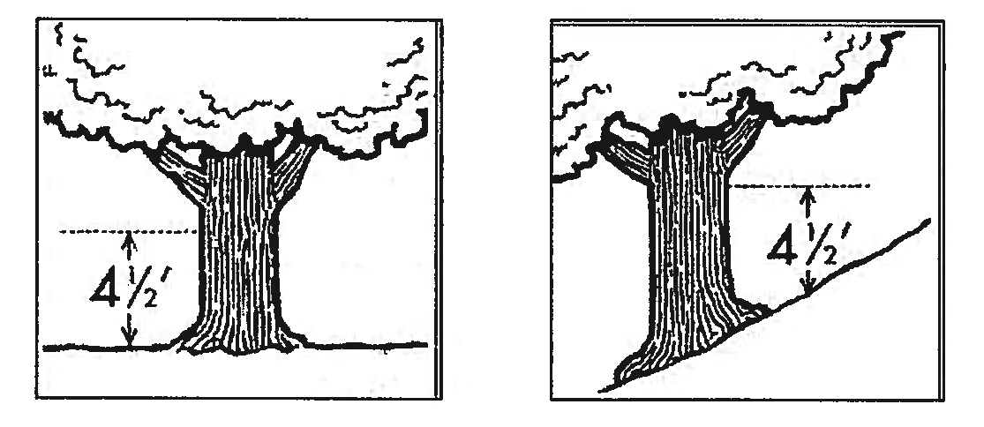
* If the tree is on a slope, measure from the high side of the slope
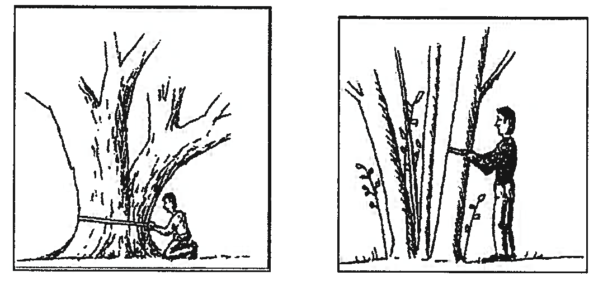
For multiple trunk trees, the circumference is deemed to equal the circumference of the largest trunk plus half the circumference of each additional trunk. For example, a tree that has three trunks with circumferences of 22", 18", and 12" you would have a circumference of 37" (22" + (½ × 18") + (½ × 12")).
(3) Clearing. The act of cutting down, removing all or a substantial part of, or damaging a tree or other vegetation that will cause the tree to decline and/or die (which includes but is not limited to chemical, physical, compaction or grading damage).
(4) Critical root zone. The root protection zone is an area with a diameter of one foot for each inch of trunk diameter measured 4½ feet above the ground, or if branching occurs at 4½ feet, the diameter is measured at the point where the smallest diameter closest to the branching occurs.
(5) Drip line. A vertical line extending from the outermost portion of the tree canopy to the ground.
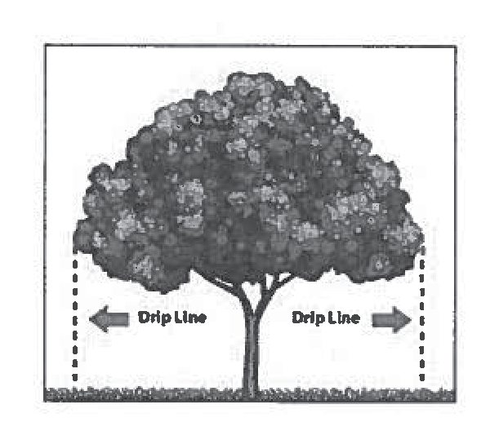
(6) Protected tree. Trees with a diameter between 12 and 24.9999 inches.
(7) Public tree. All trees partially or completely resting on public property.
(8) Removal of tree. An act that causes or may be reasonably expected to cause a tree to die, including, but not limited to: uprooting, severing the main trunk, damaging the root system by machinery, storage of materials or soil compaction; substantially changing the natural grade above the root system or around the trunk; paving with concrete, asphalt, or other impervious materials in a manner which may reasonably be expected to kill the tree.
(9) Specimen tree. Trees with a diameter of 25 inches or greater, which must be relatively upright, sound, with a solid trunk having no extensive decay; have no more than one major and several minor dead limbs; have no major insect or pathological problems; have no major pruning deficiencies, i.e. topping; and have at least 75 percent of the critical root zone in a natural, undisturbed state.
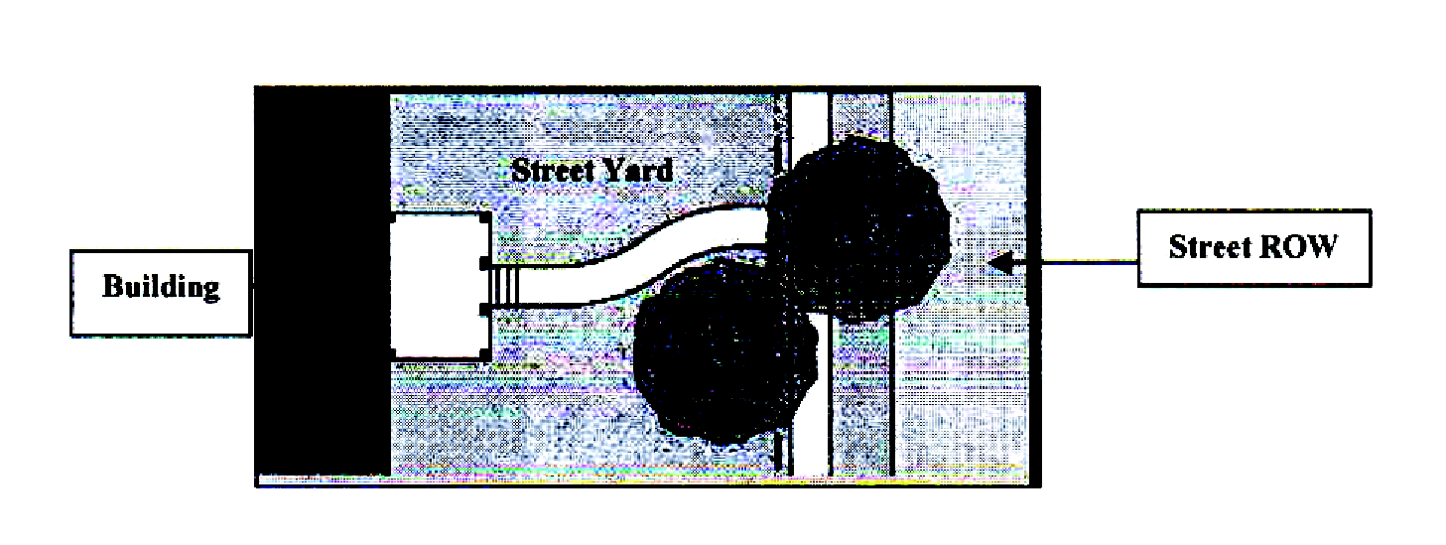
(d) Requirements.
(1) Clearing or stripping of natural vegetation on a lot is expressly prohibited. Any part of a site not used for buildings, parking, driveways, walkways, utilities, on-site septic facilities (OSSF) and approved storage areas shall be retained in a natural state, or reclaimed to its natural state.
(2) The following trees are exempt from mitigation requirements of this section:
a. Celtis occidentalis (hackberry);
b. Juniperus virginiana , Juniperis ashei (common cedar);
c. Chinaberry;
d. Mesquite;
e. Ligustrum.
Nothing in these regulations may be construed as allowing the removal of vegetation in a natural, undisturbed buffer required by zoning or land development regulations.
(3) The removal of any protected tree with a diameter of 12 inches or larger must be specifically requested by the applicant, and approved in writing by the director of planning and community development or his/her designee prior to any action being taken to remove the tree or to damage or disturb the tree in any way. The location of all trees over 12 inches in diameter to be preserved or removed within the area proposed for development shall be designated at one of the following steps in the development process:
a. On an application for a site plan for nonresidential and multifamily developments;
b. On a tree survey at the time of platting for development seeking to install infrastructure; or
c. At the time of building permit for residential lots already platted and seeking to develop or redevelop.
Removal of any such trees without city approval is expressly prohibited. Such trees shall be tagged and numbered, and numbers shall be graphically depicted on the applicable plan submitted. The tags and related numbers shall remain on the trees until the certificate of occupancy is issued.
(4) Trees over 12 inches in diameter but less than 25 inches in diameter that are not located in one of the following areas shall be replaced on-site at a ratio of 1½ caliper inches for every one caliper inch removed and shall be credited toward the number of trees required for site development:
a. Within a building footprint.
b. Within ten feet of a building footprint.
c. Within the area over the septic system.
d. Within areas necessary for reasonable site access.
e. Within areas designated for the construction or installation of public facilities such as streets or utilities, that the property owner requests and receives approval to remove may be removed.
Replacement trees installed as a function of compensation for protected tree removals are in addition to the minimum required tree density for the site.
(5) All reasonable efforts be made to save specimen trees. ("Reasonable effort" includes alternate building design, building location, parking area layout, parking area location, storm water management and equivalent or similar measures.) The removal of specimen trees, which for the purposes of these requirements are trees with 25-inch diameter or greater, must be specifically approved by the planning and zoning commission prior to any action being taken to remove the tree or to damage or disturb the tree in any way. Any specimen tree that is removed shall be replaced inch-for-inch (a ratio of two-to-one) regardless of the location on the site of the specimen tree. Replacement trees installed as a function of compensation for specimen tree removals are in addition to the minimum required tree density for the site.
(6) Trees must be planted prior to the issuance of a certificate of occupancy unless a bond for the cost of the trees is posted with the city. If a bond is posted the property owner shall have up to 12 months to plant the required trees. Trees may be donated or a fee-in-lieu of planting the required trees may be paid to the City of Kyle if the following conditions exist:
a. There is not adequate space on the site for all of the required trees to be planted on the site in which the tree(s) were removed.
b. Weather conditions are such that do not make it favorable for the required planted trees to survive and thrive.
Species, size, quantity, and delivery date of trees shall be approved by the director of parks and recreation.
(7) Tree replacement fund. Occasionally, the tree replacement requirements of this section cannot be met because a project site will not accommodate the required density of trees. In this case, the director of planning and community development is authorized to approve a contribution to the City of Kyle Tree Replacement Fund. The following standards have been established for administering these contributions:
a. The director of planning and community development must review and approve all requests for alternative compliance. In no instance may 100 percent of the required site density be met through alternative compliance. As many trees as can reasonably be expected to survive must be planted on the site in question.
b. No permit may be issued until the required contribution has been made to the tree replacement fund.
c. The amount of the contribution must be determined by the director of the community development department or his/her designee.
d. The City of Kyle Tree Replacement Fund must be used for planting trees on public property. Funds may be used for the purchase of trees, installation of trees and irrigation, and the purchase of mulch and soil amendments for the planted areas.
e. Species selected for replacement must be quality specimens and must be ecologically compatible with the specifically intended growing site. No single tree species may be used for more than 35 percent of replacement trees. Evergreens may not be used for more than 25 percent of the trees in non-buffer areas. Standards for transplanting and selecting quality replacement stock must be in accordance with standards of the International Society of Arboriculture, and American Standard for Nursery Stock.
f. Understory replacement trees may account for no greater than 25 percent of the required tree density units. The director of planning and community development is authorized to approve the additional use of understory trees for meeting density requirements on single-family lots if the size and/or layout of the lot does not allow for large overstory trees.
g. Species selection and replacement densities are subject to approval by the director of planning and community development.
(e) Exemptions to mitigation. Protected trees that are located within areas designated for the construction or installation of public facilities such as streets or utilities, shall not be required to be replaced, but must still submit a formal request for removal with the submittal of public improvement construction plans.
(f) Tree removal permit. The removal of an existing tree(s) from a development site must be in accordance with this and all other applicable ordinances of the city. Prior to the removal of any protected or specimen tree, as defined within this section, the property owner must first submit a tree removal plan for approval:
(1) Which tree(s) will be removed (as shown on a site plan).
(2) How the removal will be performed (and machinery and equipment needed), and the date and time when the anticipated removal will occur.
(3) If a specimen or protected tree is proposed for removal, a letter of justification for the removal must accompany the tree removal plan. The justification must include photographs and where appropriate, a letter of condition from a certified arborist.
(g) Tree protection. The following minimum tree protection measures must be in place for all tree save areas:
(1) Tree protection fencing. Trees identified for preservation must have protection fencing that is a minimum of four feet high installed at the edge of the critical root zones. The director of planning and community development is authorized to require the installation of four-foot high minimum chain link fencing in those areas where the likelihood of possible encroachment occurs. All tree protection zones must be designated as such with signage posted visibly on all sides of the fenced area. Signs requesting workers' cooperation and compliance with tree protection standards are recommended at the site entrance(s).
(2) Silt fences. All tree protection zones must be designed to prevent the sedimentation of erosion material. Silt fences must be placed along the outer uphill edges of tree protection zones at the development interface.
(3) Encroachment. No person may encroach into the tree protection zones. Construction activities, including, but not limited to, parking, vehicle and foot traffic, material storage, concrete washout, debris burning, and other activities must be arranged so as to prevent disturbance within the protected areas, including in and around those critical root zones of trees originating off-site and/or outside of the limits of disturbance.
(4) Utilities. Reasonable efforts must be made to locate utility lines along corridors between tree protection zones. If utility lines must encroach into the protection zones, they must be installed by horizontal, directional boring rather than trenching.
(5) Maintenance of tree protection. All tree protection devices must remain in fully functioning condition until the certificate of occupancy is issued.
a. Any tree, designated for preservation, either on or off of the development site, and either inside or outside of the project limits of disturbance, which is negligently damaged during construction or removed without the appropriate review and approval, as determined by the director of planning and community development, must be treated in accordance with the American Standards For Nursery Stock. If fatally damaged, the tree(s) must be replaced with four-inch caliper trees equal to the unit value of the tree removed. Any specimen tree damaged as described above must be replaced with trees equal to three times the caliper inches of the tree removed.
b. All tree protection zones must be mulched with at least four inches and not more than eight inches of organic mulch, such as pine straw, wood chips, tree leaves, or compost.
c. Construction activity is prohibited inside the tree save areas, including, but not limited to, grading, paving, and construction of buildings and other structures.
d. The site must be designed and maintained in a manner to ensure proper drainage in tree save areas during and after construction.
(6) Tree protection supervisors. The developer must designate a tree protection supervisor. This person must demonstrate knowledge in the area of tree protection practices during construction and must be on-site to ensure tree protection measures are enforced. The tree protection supervisor must participate in a pre-construction conference with the city prior to the commencement of any development. The tree protection supervisor must notify the director of planning and community development immediately should any tree damage occur on the site.
(7) Inspections. Tree protection inspections must be performed by a certified arborist or registered forester during construction. The inspections must be conducted prior to the commencement of development, immediately following the clearing and grubbing phase, immediately following the grading phase, and at the end of the project before a certificate of occupancy (commercial developments) is issued or the final plat approved (residential developments). The site must be inspected to ensure all tree protection regulations are being met and to identify any existing or developing tree-related problems that require treatment. An inspection report must be prepared and certified by the inspector and submitted to the director of planning and community development. Any damage noted must be treated in accordance with the recommendation of the inspector prior to the issuance of a certificate of occupancy or approval of the final plat. The director of planning and community development is authorized to require additional reports should he/she determine significant construction damage has occurred, the tree protection supervisor has failed to enforce minimum protection standards, or if other development processes, including but not limited to utility placement and building construction, may impact the tree save areas.
(8) [ Prohibited activities. ] Activities hazardous to the health of any protected tree being preserved are prohibited, including but not limited to the following:
a. Physical damage.
b. Equipment cleaning and liquid disposal. Cleaning equipment, depositing or allowing harmful liquids to flow overland within the limits of the critical root zone. This includes paint, oil, solvents, asphalt, concrete, mortar, tar or similar materials.
c. Grade changes. Grade changes (cut or fill) within the limits of the critical root zone.
d. Material storage. Storing materials intended for use in construction or allowing waste materials due to excavation or demolition to accumulate within the limits of the drip line.
e. Tree attachments. Attaching to a tree any signs, wires, or other items, other than those of a protective nature.
f. Vehicular traffic. Vehicular and/or construction equipment traffic, parking, or storage within the limits of the drip line, other than on pre-existing or approved pavement. This restriction does not apply to single incident access within the drip line for purposes of clearing underbrush, vehicular access necessary for emergency services, routine utility maintenance, emergency restoration of utility service, or routine mowing operations.
g. Utility encroachment. Installation of utilities and appurtenances within the drip line.
h. Excavation and trenching. Excavation and trenching within the limits of the drip line.
(h) Penalty. Any person who shall violate any provision of this section or technical codes adopted herein, or shall fail to comply therewith, or with any of the requirements thereof shall be liable for a fine not to exceed the sum of $2,000.00 per offense. Each violation and each day the violation exists shall constitute a separate offense.
( Ord. No. 725 , § 2(Exh. A), 5-8-2013; Ord. No. 912 , § 1(Exh. A), 10-18-2016)
Appendix A. - Tree Selection.
(1) Trees selected for planting must meet minimum requirements as provided below and in the American Standard of Nursery Stock.
(2) Trees selected for planting must be free from injury, pests, disease, or nutritional disorders.
(3) Trees selected for planting must be of good vigor. The determination of vigor is a subjective evaluation, and dependent upon species variability. The following criteria is generally used for the determination of vigor:
(4) Foliage should have a green or dark green color. Vigorous trees will have large leaves and dense foliage when compared to trees with poor vigor.
(5) Shoot growth for most vigorous trees will be at least one foot per year. At least one-half of the branches should arise from the top one-third and one-half from the center one-third.
(6) Bark texture can denote vigor. Smooth or shiny bark on the trunk and branches of a young tree usually signifies good vigor, conversely, rough and full bark could indicate poor vigor.
(7) Trunk taper. The trunks of vigorous trees will generally have an increase in diameter with a decrease in height. Trees with reverse tapers or no taper should be avoided.
(8) Root color. Young roots of most trees will be light in color.
(9) Trees selected for planting must be free of root defects. Two types of root defects generally occur:
(10) Kinked roots, in which taproots, major branch roots, or both are bent more than 90 degrees with less than 20 percent of the root system originating above the kink. A tree with such roots will probably bend at the soil line when released from a supporting stake.
(11) Circling or girdling roots which circle 80 percent or more of the root system by 360 degrees or more. A tree with such roots would ultimately have less than 20 percent of its system available for support.
( Ord. No. 912 , § 1(Exh. A), 10-18-2016)
Appendix B. - Tree Transplanting.
The transplanting of new trees can result in major injury to their root system. If proper transplanting techniques are employed, conditions will be more favorable for tree recovery, and the rate of attrition for newly planted trees will be reduced. Transplanting procedures must follow standards established by the International Society of Arboriculture in the Trees and Shrub Transplanting Manual, and the booklet by the Georgia Extension Service entitled "Plant Trees Right!" The following is a summary several of the more important considerations provided in the manual and booklet.
Preplanting considerations:
(1) Only healthy trees with a well-developed root system and a well-formed top, characteristic of the species should be planted.
(2) Trees selected for planting must be compatible with the specific site conditions.
(3) The ability of a species to regenerate a new root system and to become reestablished should be considered. Generally, deciduous trees should be planted in the fall after leaf drop, or in early spring before bud break. There are indications that bare root trees will reestablish more readily if planted in early spring just prior to bud break.
Planting procedures:
(1) Planting holes should be at least three times the diameter of the root ball.
(2) Trees should not be planted deeper than they were in their former location or container.
(3) Spade compacted bottom and sides of the planting hole should be roughed or scarified to allow the penetration of developing roots.
(4) Good water drainage from the bottom of the planting hole is essential for root regeneration.
(5) Once the transplanted tree is set, the hole should be backfilled with soil of good texture and structure. There are indications that a backfill with native soil alone may be inadequate. Traditionally, backfill material is comprised of a mix of native soil, organic matter such as peat, and inorganic material such as perlite or vermiculite in a 1:1:1 ratio.
(6) The addition of fertilizer to backfill soil can cause root injury, and is therefore not recommended. If fertilizer must be added, a low rate should be used. Approximately 1.5 pounds of nitrogen per cubic yard of backfill is recommended for bare root plants, and 2.5 pounds of nitrogen per cubic yard of backfill for balled and burlapped trees.
(7) The backfill should be gently tamped (but not compacted), and soaked for settling.
(8) The soil should be slightly mounded to allow for settling; a ridge or dike around the perimeter of the hole can facilitate watering.
( Ord. No. 912 , § 1(Exh. A), 10-18-2016)
Appendix C. - Planting Standards.
(1) After selecting a suitable location, mark out a planting area that is five times the diameter of the planting ball. Use a rototiller or shovel to loosen and mix the soil in this entire area to a depth of about 12 inches.
(2) In the center of the prepared area, dig a shallow hole to set the tree or shrub. The hold should allow the root ball to sit on solid ground rather than loose soil. Once the ball is set the hole, its upper surface should be level with the existing soil.
(3) After the tree is properly situated, cut and remove the rope or wires holding the burlap in place and securing any part of the tree.
(4) Backfill around the root area, and gently firm the soil to prevent major air pockets. Do not pack the soil. Water can be used to help the soil settle and prevent overpacking. Rake the soil even over the entire area, and cover it with two to four inches of mulch. Maintaining the mulch layer carefully will improve tree growth substantially.
(5) Water berms or dikes are not recommended as they encourage abnormal root growth.
(6) It is best not to stake the tree, but if wind is a problem or the tree starts to lean, support it with a flexible stake so the trunk will sway in the wind. The movement is necessary for building the trunk's strength. Remove the stake and wire after one growing season since leaving wire or string around the tree can cause death.
(7) Do not wrap the trunk with "protective" tape. It will slow the tree's ability to adapt to the site and provide a home for insects. Tree bark needs air and sunlight in order to build a healthy protective sheath.
( Ord. No. 912 , § 1(Exh. A), 10-18-2016)
Secs. 53-996—53-1000. - Reserved.
DIVISION 2. - OUTDOOR LIGHTING REGULATIONS

Sec. 53-1001. - Purpose.
The purpose of this division is to provide regulations for outdoor lighting that will:
(1) Permit the use of outdoor lighting that does not exceed the minimum levels specified in the Illuminating Engineering Society recommended practices for nighttime safety, utility, security, productivity, enjoyment, and commerce.
(2) Minimize adverse offsite impacts of lighting such as light trespass, and obtrusive light.
(3) Curtail light pollution, reduce sky glow and improve the nighttime environment for astronomy.
(4) Help protect the natural environment from the adverse effects of night lighting from gas or electric sources.
(5) Conserve energy and resources to the greatest extent possible.
( Ord. No. 909 , § 1(Exh. A), 8-17-2016)
Sec. 53-1002. - Scope.
(a) This division applies to all new nonresidential and multifamily development requiring site plan approval subject to zoning requirements. Any nonresidential (e.g. businesses) or multifamily property already in existence on the effective date of this division shall be exempt from this division except, all nonresidential and multifamily properties going through re-development through extension, reconstruction, resurfacing, or structural alteration of at least 50 percent increase in size or value, whichever is less, must come into compliance with this division. Site plan approval shall be conditioned on compliance with this division.
(b) Nothing herein shall be construed as preventing or limiting the city from applying this division to the ETJ through agreements with property owners, or as a term affixed to a conditional approval (such as a variance).
( Ord. No. 909 , § 1(Exh. A), 8-17-2016)
Sec. 53-1003. - Exemptions.
The following are exempt from the application of the regulations of this division:
(1) Lighting equipment required by law to be installed on motor vehicles or lighting required for the safe take-off and landing aircraft.
(2) Temporary holiday decorations, for the time period commencing 30 days prior to the holiday, and extending not later than 30 days after the holiday.
(3) Lighting needed during activities of law enforcement, fire and other emergency services.
(4) Lighting employed during emergency repairs of roads and utilities may be unshielded.
(5) Temporary lighting required to save lives or property from imminent peril.
(6) In lighting zones 2, 3 and 4, low voltage landscape lighting controlled by an automatic device that is set to turn the lights off at one hour after the site is closed to the public or at a time established by the authority.
( Ord. No. 909 , § 1(Exh. A), 8-17-2016)
Sec. 53-1004. - Definitions.
Additions means additions to existing establishments of 25 percent or more in terms of gross floor area, seating capacity, or parking spaces, either with a single addition or with cumulative additions subsequent to the effective date of this division.
Foot-candle means a measure of luminance, i.e. visible light falling on a given surface. One foot-candle is equal to one lumen per square foot. Illumination can be measured in foot-candles both horizontally and vertically with an illumination photometer.
Full cut-off fixtures means fixtures, as installed, that are designed or shielded in such a manner that all light rays emitted by the fixture, either directly from the lamps or indirectly from the fixture, are projected below a horizontal plane running through the lowest point on the fixture where light is emitted.
Glare means lighting entering the eye directly from luminaires or indirectly from reflective surfaces that causes visual discomfort or reduced visibility.
Holiday lighting means lighting used for a specific celebration which may be one of the following types:
(1) Festoon-type low-output lamps, limited to small individual bulbs on a string.
(2) Low-output lamps used to internally illuminate yard art.
(3) Flood or spot lights producing less than 2,000 lumens each, whose light source is not visible from any other property, and which are used only as temporary lighting.
IESNA means the Illuminating Engineering Society of North America, an organization that establishes updated standards and illumination guidelines for the lighting industry.
IDA means the International Dark Sky Association.
Light trespass means light emitted from fixtures designed or installed in a manner that unreasonably causes light to fall on a property other than the one where the light is installed, in a motor vehicle driver's eyes, or upwards toward the sky.
Lighting means any source of light that does not include natural light emitted from celestial objects or fire. The term includes any type of lighting, fixed or movable, designed or used for outdoor illumination of buildings or homes, including lighting for billboards, streetlights, canopies, gasoline station islands, searchlights used for advertising signs, and area-type lighting. The term includes luminous elements or lighting attached to structures, poles, the earth, or any other location.
Lighting zones reflect the base (or ambient) light levels desired by a community. The use of lighting zones (LZ) was originally developed by the International Commission on Illumination (CIE) and appeared first in the US in IES Recommended Practice for Exterior Environmental Lighting, RP-33-99.
Logo means a representation or symbol adopted by a business, organization, or an individual used to promote instant public recognition.
Lumen means the unit of measurement used to quantify the amount of light produced by a bulb or emitted from a fixture (as distinct from "watt" a measure of power consumption). For the purposes of this division, the lumen output values shall be the initial lumen output ratings of a lamp. The lumen rating associated with a given lamp is generally indicated on its packaging or may be obtained from the manufacturer. (Abbreviated "lm.")
Luminaire means the complete lighting unit (fixture) consisting of a lamp, or lamps and ballasts, together with the parts designed to distribute the light (reflector, lens, diffuser), to position and protect the lamps, and to connect the lamps to the power supply.
Luminous elements (of a light fixture) means the lamp (light bulb), any diffusing elements, and surfaces intended to reflect or refract light emitted from the lamp individually or collectively compromise the luminous elements of a light fixture (luminaire).
LZ1 (Light Zone 1) means the IESNA's recommended default zone for rural and low-density residential areas for low ambient lighting levels.
Major addition means enlargement of fifty percent or more of the building's gross floor area, seating capacity, or parking spaces, either with a single construction project or cumulative series of construction projects, after the enactment of this division. The term also includes replacement of 25 percent or more of installed outdoor lighting.
Outdoor lighting means temporary or permanent lighting that is installed, located or used in such a manner to cause light rays to shine outdoors. Nonresidential fixtures that are installed indoors that cause light to shine outside are considered outdoor lighting for the intent of this division. (See Figure A.) Residential fixtures installed indoors generating more than 6,200 lumens (approximately equal to a 300 watt incandescent bulb) that cause light to shine outside are also a nonresidential application of indoor lighting, labeled FS, which will be subject to this division and indoor lighting, labeled A, which is installed so that it is not subject to this division.
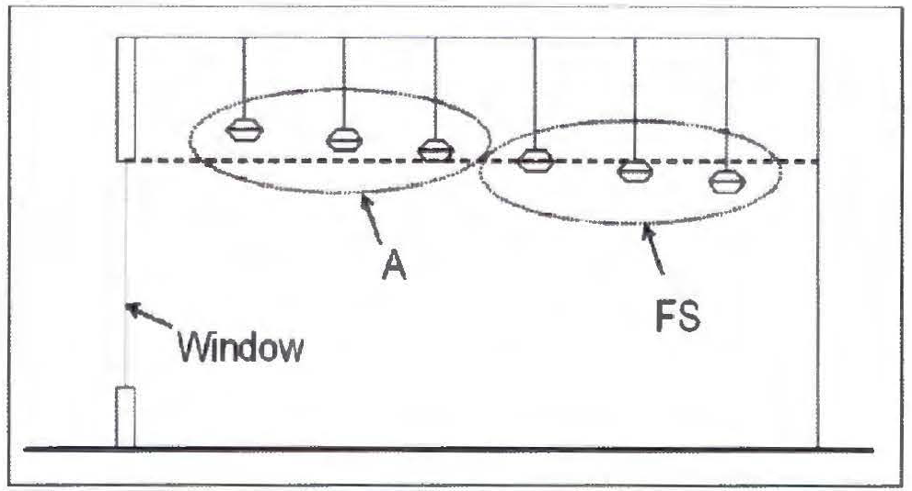
Figure A: Elevation view showing a nonresidential application of indoor lighting, labeled FS, which will be subject to this article and indoor lighting, labeled A, which is installed so that it is not subject to this article.
Shielded lights means outdoor light fixtures shielded or construction so that no light rays are emitted by the installed fixture at angles above the horizontal plane as certified by a photometric test report. The bulb is not visible with a shielded light fixture, and no light is emitted from the sides of the fixture. This light is also considered a full cut-off fixture. Examples of fully shielded or full cut-off light fixtures: public street and pedestrian lighting, parking lots, pathways, recreational areas, billboards, product display area lighting, and building overhangs and open canopies.
(1) The light bulb should not extend below the lampshade to ensure the best optimal light direction
Sky glow means the brightening of the nighttime sky that results from scattering and reflection of artificial light by moisture and dust particles in the atmosphere. Sky glow is caused by light directed or reflected upwards or sideways and reduces one's ability to view the night sky.
Temporary lighting means lighting intended for uses which by their nature are of limited duration. For example: holiday decorations, civic events, or construction projects.
Uplighting means lighting that is directed in such a manner as to shine light rays above the horizontal plane.
( Ord. No. 909 , § 1(Exh. A), 8-17-2016)
Sec. 53-1005. - New lighting.
(a) General. All outdoor lighting shall be installed in conformance with the provisions of this article, applicable electrical codes, energy codes, and building codes, except as provided herein.
(b) Prohibition. It is an offense to install outdoor lighting that does not comply with the standards established by this article.
(c) Nonresidential. All outdoor lighting installed on nonresidential properties shall conform to the standards by this article, except as provided herein.
(d) Residential. All outdoor lighting installed on residential properties that is affixed to a construction project for which a building permit is required under this code shall conform to the standards established by this article.
( Ord. No. 909 , § 1(Exh. A), 8-17-2016)
Sec. 53-1006. - Nonconforming existing lighting.
(a) General.
(1) All existing outdoor lighting in commercial zoning districts that was legally installed before the enactment of this division, that does not conform with the standards specified imposed by this article shall be considered nonconforming. Nonconforming outdoor lighting is allowed to remain until required to be replaced pursuant to the terms of this article.
(2) If more than 50 percent of the total appraised value of a structure has been destroyed, the nonconforming status expires and the development site's previously nonconforming outdoor lighting must be removed and may only be replaced in conformity with the standards of this division.
(3) Nonconforming outdoor lighting shall be brought into conformance with this article as follows:
a. Nonresidential major addition. All existing outdoor lighting located on a subject property that is part of an application for a rezoning application, conditional use permit, subdivision approval, or a building permit for a major addition is required to be brought into conformance with this article before final inspection, issuance of a certificate of occupancy, or final plat recordation, when applicable. For the following permits issued by the city, the applicant shall have a maximum of 90 days from date of permit issuance to bring the lighting into conformance: site development permit, sign permit for an externally or internally-illuminated outdoor sign, initial alcoholic beverage permit, initial food establishment permit, and on-site sewage facility permit.
b. Residential addition or remodel. Nothing herein shall be construed to terminate a residential property's nonconforming status as a result of an addition or remodel.
c. Abandonment of nonconformity. A nonconforming structure and/or use shall be deemed abandoned if the structure and/or use remains vacant/dormant/unused for a continuous period of six months. In that instance, the site's nonconforming status expires and the site's previously nonconforming outdoor lighting must be removed and may only be replaced in conformity with the standards of this article.
d. It is unlawful to expand, repair or replace outdoor lighting that was previously nonconforming, but for which the prior nonconforming status has expired, been forfeited, or otherwise abandoned.
e. New uses or structures, or change of use. Whenever there is a new use of a property (zoning or variance change) or the use on the property is changed, all outdoor lighting on the property shall be brought into compliance with this division before the new or changed use commences.
f. Major addition. All existing outdoor lighting located on a subject property that is part of an application for a rezoning application, conditional use permit, subdivision approval, or a building permit for a major addition is required to be brought into conformance with this division before final inspection, issuance of a certificate of occupancy, or final plat recordation, when applicable.
(b) Prohibitions. It is unlawful to expand or replace outdoor lighting that was previously nonconforming, but for which the prior nonconforming status has expired, been forfeited, or otherwise abandoned. Nothing in this division shall prohibit the usual and customary repair, replacement of components, or maintenance of nonconforming outdoor lighting; however, damage or destruction of nonconforming outdoor lighting which requires repair or replacement of wiring, and/or structural components of the housing, mount, and/or base, is not permissible. Such lighting, if re-established, must be replaced with compliant fixtures.
( Ord. No. 909 , § 1(Exh. A), 8-17-2016)
Sec. 53-1007. - Submission of plans and evidence of compliance.
(a) Plan requirements. All nonresidential and multifamily building permit applications must include an outdoor lighting plan which includes the following information:
(1) The location of all existing and proposed light fixtures (should be included on the site plan) with projected hours of use.
(2) Types of timing devices used to control the hours set for illumination.
(3) A lighting fixture table that includes the total area (square footage) to be illuminated, the cut-off fixture descriptions, lamp source types (i.e., incandescent, low pressure sodium, compact fluorescent, LED, etc.), lumen output, wattage, number of lamps, and mounting height of all existing and proposed lamps.
(4) Lighting manufacturer-supplied specification "cut sheets" that include photographs for all existing and proposed light fixtures.
(5) For all plans of more than three fixtures: A calculation summary indicating foot-candle levels on the lighting plan, noting the maximum, average and minimum, as well as the uniformity ratio of maximum to minimum, and average to minimum levels.
(6) A statement signed by the property owners and acknowledged before a notary public that the applicant has received notification of the provisions of this division and that the photometric measurement shall be zero at all locations three feet past the property line perimeter.
(b) Inspection. Verification that a nonresidential and multifamily construction project requiring a building permit application has complied with the provisions of this division shall occur during the final electrical inspection by the certifying and sealing engineer.
( Ord. No. 909 , § 1(Exh. A), 8-17-2016)
Sec. 53-1008. - Lighting zones.
The lighting zones shall determine the limitations for lighting as specified in this division. The lighting zones shall be categorized as follows:
(1) LZ-0: No ambient lighting.
a. Areas where the natural environment will be seriously and adversely affected by lighting. Impacts include disturbing the biological cycles of flora and fauna and/or detracting from human enjoyment and appreciation of the natural environment. Human activity is subordinate in importance to nature. The vision of human residents and users is adapted to the darkness, and they expect to see little or no lighting. When not needed, lighting should be extinguished.
b. Default zone for wilderness and protected wildlife areas, parks and preserves, and undeveloped rural areas.
c. Shall be applied to areas in which permanent lighting is not expected and when used, is limited in the amount of lighting and the period of operation. Special review should be required for any permanent lighting in this zone. Some rural communities may choose to adopt LZ-0 for residential areas.
(2) LZ-1: Low ambient lighting.
a. Areas where lighting might adversely affect flora and fauna or disturb the character of the area. The vision of human residents and users is adapted to low light levels. Lighting may be used for safety and convenience but it is not necessarily uniform or continuous. After curfew, most lighting should be extinguished or reduced as activity levels decline.
b. Zoning districts: A; R-1; R1-1; R1-2; R-1-A; R-1-T; R-2; M-2; M-3.
c. Default zone for rural and low density residential areas, including residential single- or two-family; agricultural zone districts; rural residential zone districts; business parks; open space include preserves in developed areas.
d. Lighting zone 1 pertains to areas that desire low ambient lighting levels. These typically include single- and two-family residential communities, rural town centers, business parks, and other commercial or industrial/storage areas typically with limited nighttime activity. May also include the developed areas in parks and other natural settings.
(3) LZ-2: Moderate ambient lighting.
a. Areas of human activity where the vision of human residents and users is adapted to moderate light levels. Lighting may typically be used for safety and convenience but it is not necessarily uniform or continuous. After curfew, lighting may be extinguished or reduced as activity levels decline.
b. Zoning districts: R-3-1; R-3-2; R-3-3; HS; CC.
c. Default zone for light commercial business districts and high density or mixed-use residential districts. Includes neighborhood business districts; churches, schools and neighborhood recreation facilities; and light industrial zoning with modest nighttime uses or lighting requirements.
d. Lighting zone 2 pertains to areas with moderate ambient lighting levels. These typically include multifamily residential uses, institutional residential uses, schools, churches, hospitals, hotels/motels, commercial and/or businesses areas with evening activities embedded in predominantly residential areas, neighborhood serving recreational and playing fields and/or mixed use development with a predominance of residential uses.
(4) LZ-3: Moderately high ambient lighting.
a. Areas of human activity where the vision of human residents and users is adapted to moderately high light levels. Lighting is generally desired for safety, security and/or convenience and it is often uniform and/or continuous. After curfew, lighting may be extinguished or reduced in most areas as activity levels decline.
b. Zoning districts: CBD-1; CBD-2; R/S; C-1; C-2; E; T/U.
c. Default zone for large cities' business district. Includes business zone districts; commercial mixed use; and heavy industrial and/or manufacturing zone districts.
d. Lighting zone 3 pertains to areas with moderately high lighting levels. These typically include commercial corridors, high intensity suburban commercial areas, town centers, mixed use areas, industrial uses and shipping and rail yards with high night time activity, high use recreational and playing fields, regional shopping malls, car dealerships, gas stations, and other nighttime active exterior retail areas.
(5) LZ-4: High ambient lighting.
a. Areas of human activity where the vision of human residents and users is adapted to high light levels. Lighting is generally considered necessary for safety, security and/or convenience and it is mostly uniform and/or continuous. After curfew, lighting may be extinguished or reduced in some areas as activity levels decline.
b. Zoning districts: HI; W; C/M; LI.
c. Not a default zone. Includes high intensity business or industrial zone districts. LZ-4 may be used for extremely unusual installations such as high-density entertainment districts, and heavy industrial uses.
d. Lighting zone 4 pertains to areas of very high ambient lighting levels. LZ-4 should only be used for special cases and is not appropriate for most cities.
Note— Lighting zone designation for PUD districts will be determined on a case-by-case basis, at the discretion of the mayor and city council, at the time of request for zoning approval.
( Ord. No. 909 , § 1(Exh. A), 8-17-2016)
Sec. 53-1009. - General requirements.
This division sets out the requirements that apply to all lighting, both residential and nonresidential.
(1) Conformance with all applicable codes. All outdoor lighting shall be installed in conformance with the provisions of this division, applicable electrical and energy codes, and applicable sections of the building code.
(2) Applicability. Except as described below, all outdoor lighting installed after the date of effect of this division shall comply with these requirements. This includes, but is not limited to, new lighting, replacement lighting, or any other lighting whether attached to structures, poles, the earth, or any other location, including lighting installed by any third party.
( Ord. No. 909 , § 1(Exh. A), 8-17-2016)
Sec. 53-1010. - Prohibitions.
(a) It shall be unlawful and an offense for any person/entity to do the following:
(1) Install lighting contrary to this division; and/or
(2) Fail to comply with any terms or conditions set forth in a permit issued under this division.
(b) Fixtures.
(1) The installation of any mercury vapor fixture or lamp for use as outdoor lighting is prohibited.
(2) The installation of any wall pack style fixture for use as outdoor lighting is prohibited unless the fixture is rated by the manufacturer as full cut-off. Examples of acceptable wall packs, when mounted with light directed downward only are shown in Figure I.
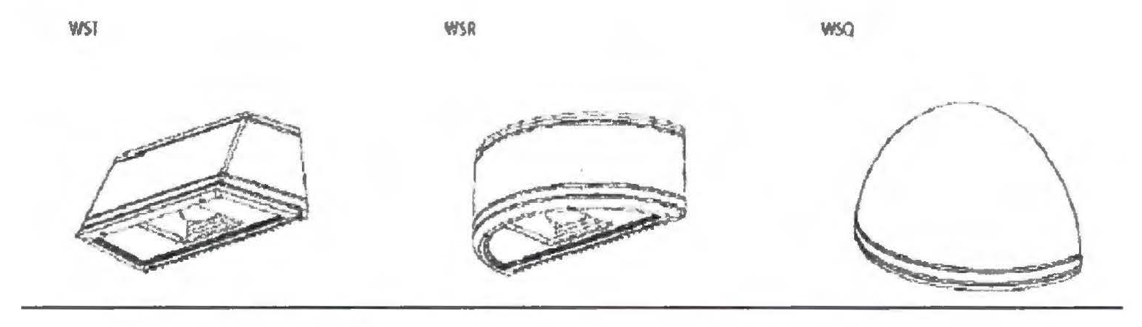
Figure I: Examples of Acceptable Wall Packs
(3) The installation of any barn-light style fixture for use as outdoor lighting is prohibited unless the fixture includes a full opaque reflector instead of the standard translucent lens. An example of barn-light style with and without the required opaque reflector is shown in Figure J.
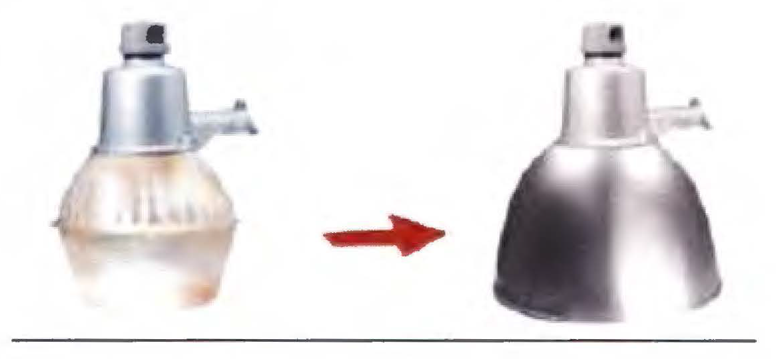
Figure J: Prohibited Fixture (left) vs.
(4) The operation of searchlights for advertising purposes is prohibited.
( Ord. No. 909 , § 1(Exh. A), 8-17-2016)
Sec. 53-1011. - Shielding and total light trespass standards.
(a) Parking. All parking lot lighting shall have no light emitted above an angle of 90 degrees (i.e., light shall not shine above the horizon).
(b) Shielding. All outdoor lighting, except governmental owned streetlights, shall be shielded so that luminous elements of the fixture are not visible from any other property. Mounting height or proximity to property lines may cause the luminous elements of a light fixture to need additional shielding. The following are examples of shielding and lack of shielding (see Figures B and C).
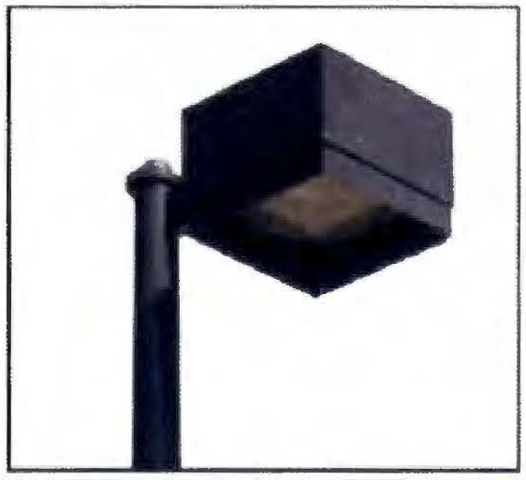
Figure B: Typical Shielded Outdoor Lighting
In Figure C (below), the lights on the left are nonconforming. Those on the right can be used in most cases. However, the mounting height and proximity to the property line may cause them to need additional shielding to prevent the luminous elements from being visible from any other property.
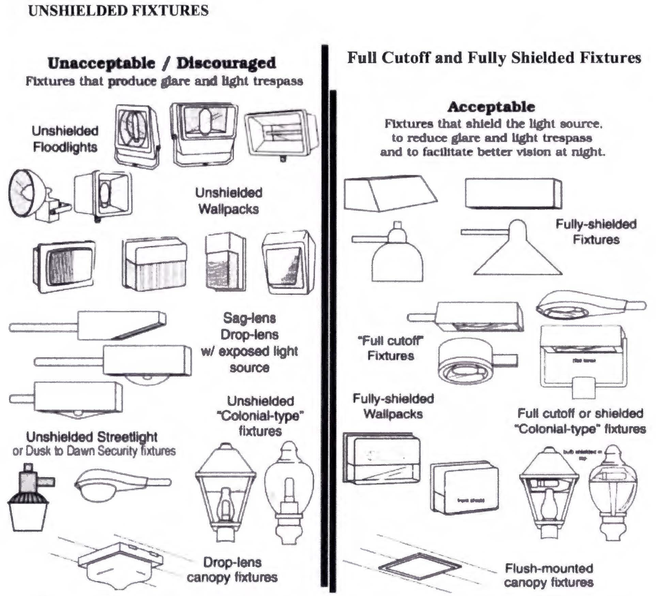
Figure C: Examples of Prohibited and Permitted Outdoor Lighting
(c) Public lighting. Governmental owned street lights shall meet the qualifications to be full cut-off fixtures in order to limit light trespass (see Figure D).
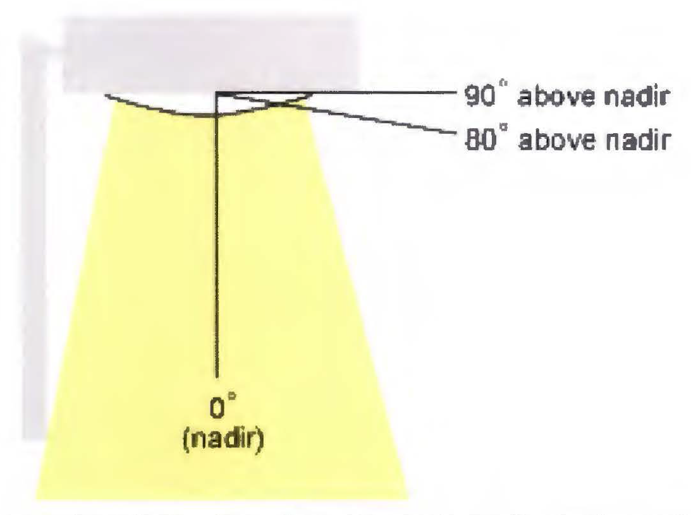
Figure D: Full Cut-Off Fixture that Limits Light Trespass
(d) Prohibitions.
(1) Outdoor uplighting is prohibited, except in cases where the fixture is shielded by a roof overhang or similar structural shield and a licensed architect or engineer has stamped a prepared lighting plan that ensures that the light fixtures(s) will not cause light to extend beyond the structural shield, and except as specifically permitted in this division.
(2) Outdoor lighting fixtures, except uplighting covered in this division, are not allowed to have light escape above a horizontal plane running through the lowest point of the luminous elements (see Figures E and F).
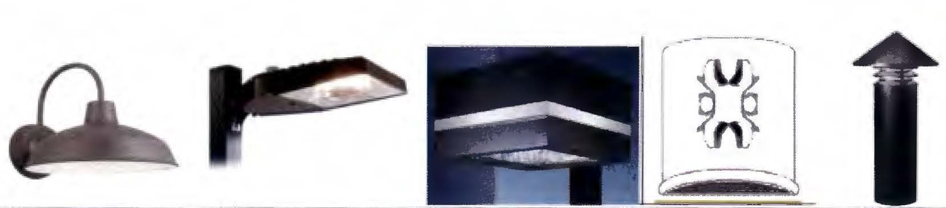
Figure E: Permitted Fixtures with Zero Lighting above Horizontal Plane
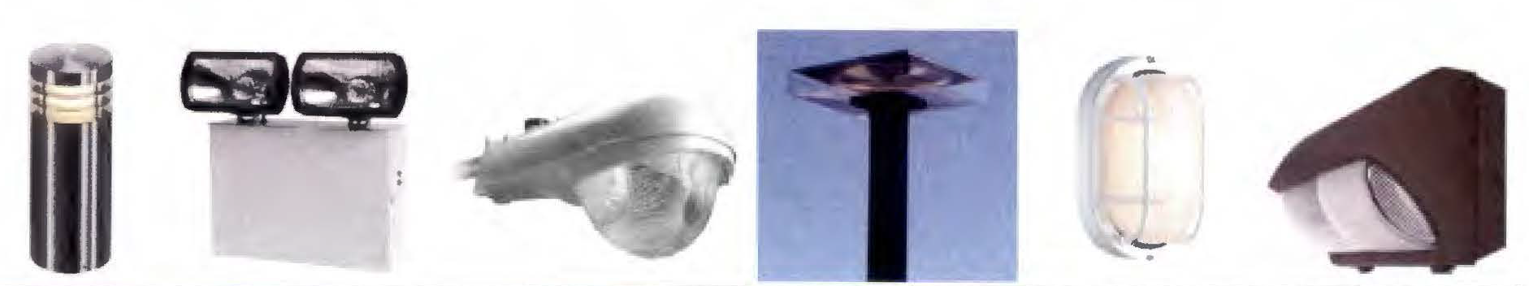
Figure F: Prohibited Fixtures with Light Escape above Horizontal Plane
(3) There shall be no light trespass across property lines. The photometric measurement shall be zero at all locations three feet past the property perimeter.
(e) Outdoor recreational facilities. Outdoor recreational facilities are subject to the shielding requirements in this division. Where fully shielded fixtures are not available, lighting fixtures using external louvers or shields that, in the final installed configuration, extend to within three inches on the lowest portion of the light fixture opening are required (see Figure G). The fixtures shall be installed and maintained with aiming angles that permit no greater than one percent of the light emitted by each fixture to project above the horizontal line.
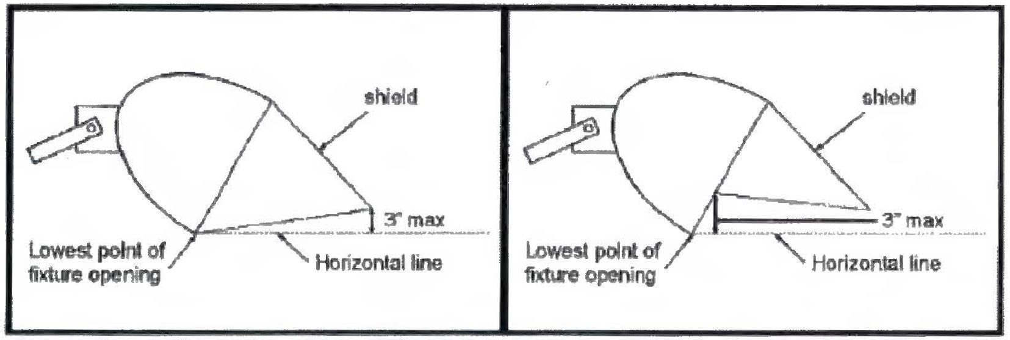
Figure G: Sports Lighting where Fully Shielded Fixtures are Not Available
( Ord. No. 909 , § 1(Exh. A), 8-17-2016)
Sec. 53-1012. - Lighting for outdoor signs and panels.
Refer to the city sign ordinance Section 7-13 Illumination for sign lighting regulations (page 1).
( Ord. No. 909 , § 1(Exh. A), 8-17-2016)
Sec. 53-1013. - Neon lighting.
Neon lighting is permitted. Such lighting shall be subject to the shielding requirements of this division unless exempted.
( Ord. No. 909 , § 1(Exh. A), 8-17-2016)
Sec. 53-1014. - Lighting curfews.
(a) Outdoor lighting. Outdoor lighting intended to be illuminated for more than 30 minutes after closing, or for the completion of activities after closing, must be reduced to 25 percent or less of the normal lumen output. Motion sensor activation may be allowed to cause the light to resume normal lumen output only when activated and to be reduced back to 25 percent of less of normal lumen output within five minutes after activation has ceased, and the light shall not be triggered by activity off the property.
(b) Sign illumination. Illumination for all advertising signs, both externally and internally illuminated, shall be turned off by the later of closing time or 11:00 p.m.; provided, however, that such signs may be turned back on prior to sunrise, but no more than one hour prior to opening.
(c) Street lighting. Street lighting, other than at the intersection of roadways, shall utilize half-night photocells or timers to turn off lights halfway between dusk and dawn.
(d) Outdoor recreational facilities. Lighting for outdoor recreational facilities is allowed between one hour prior to sunset and 11:00 p.m., unless it is needed to complete a specific organized activity or event already in progress at 11:00 p.m.
( Ord. No. 909 , § 1(Exh. A), 8-17-2016)
Sec. 53-1015. - Variances.
The city board of adjustment may grant variances to the requirements of this division, pursuant to the applicable policies and procedures established in article IX of this chapter.
( Ord. No. 909 , § 1(Exh. A), 8-17-2016)
Sec. 53-1016. - Civil and criminal penalties.
The city shall have the power to administer and enforce the provisions of this division as may be required by governing law. Any person violating any provision of this division is subject to suit for injunctive relief as well as prosecution for criminal violations.
( Ord. No. 909 , § 1(Exh. A), 8-17-2016)
Sec. 53-1017. - Public nuisance.
(a) General. Any violation of this division that results in light trespass or an unreasonable interference with the common and usual use of neighboring and/or nearby property is hereby declared to be a public nuisance, which is prohibited by this division.
(b) Offense. It is an offense under this division for a person to emit light onto the property of another unreasonably interfering with the neighboring and/or nearby property owner's use and enjoyment of their property.
( Ord. No. 909 , § 1(Exh. A), 8-17-2016)

